How to add national languages to the subtitles of youtube videos:
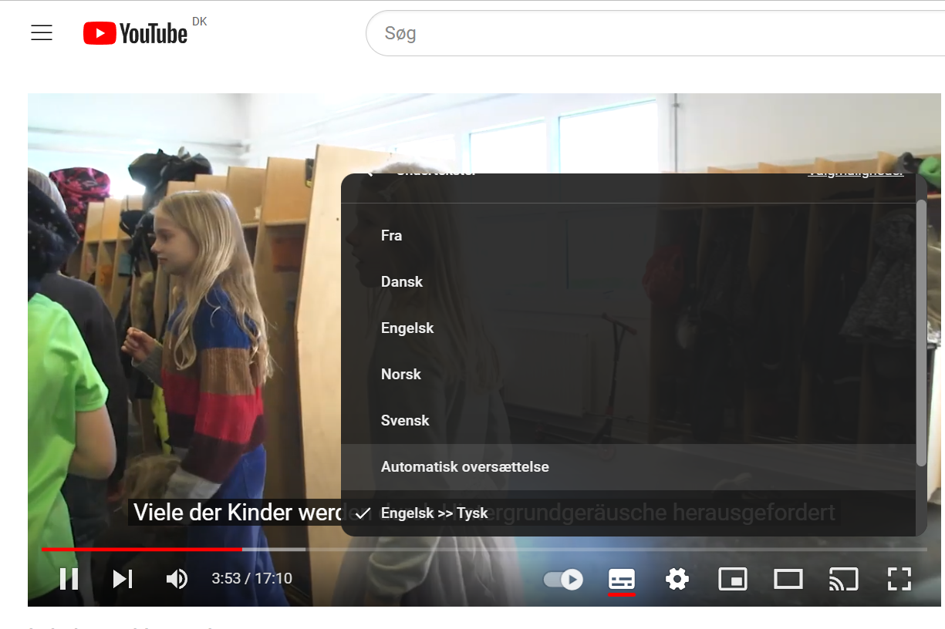
3. Choose ”Automatisk oversættelse” (automatic translation)
2. point to the cogwheel
1.Add subtitles here

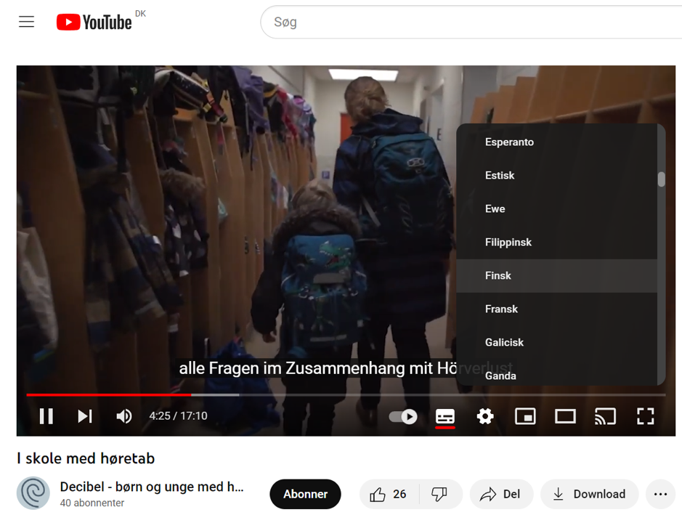

4. Choose your own language

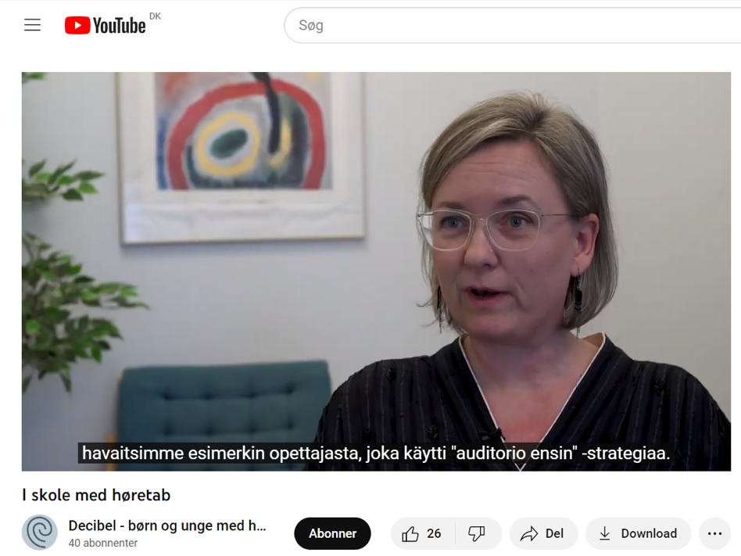
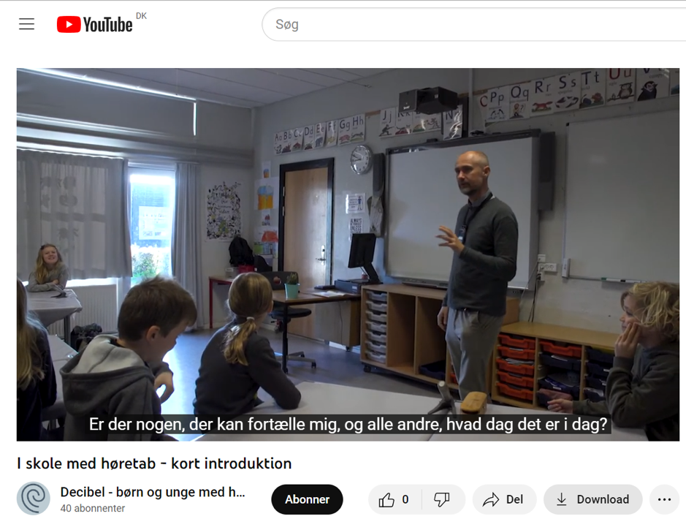
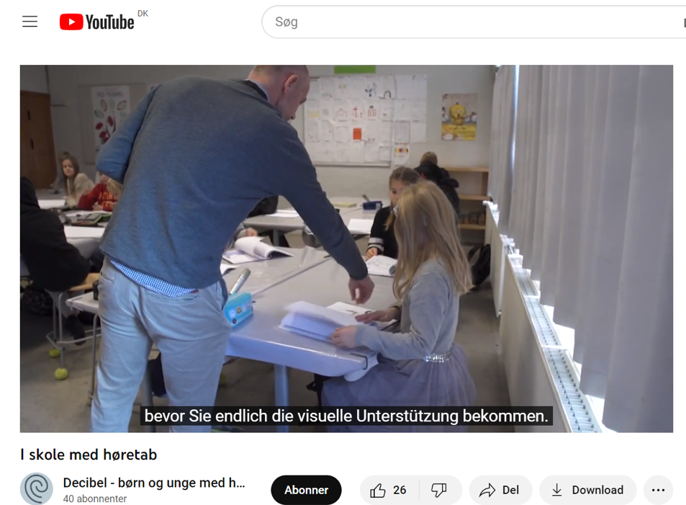
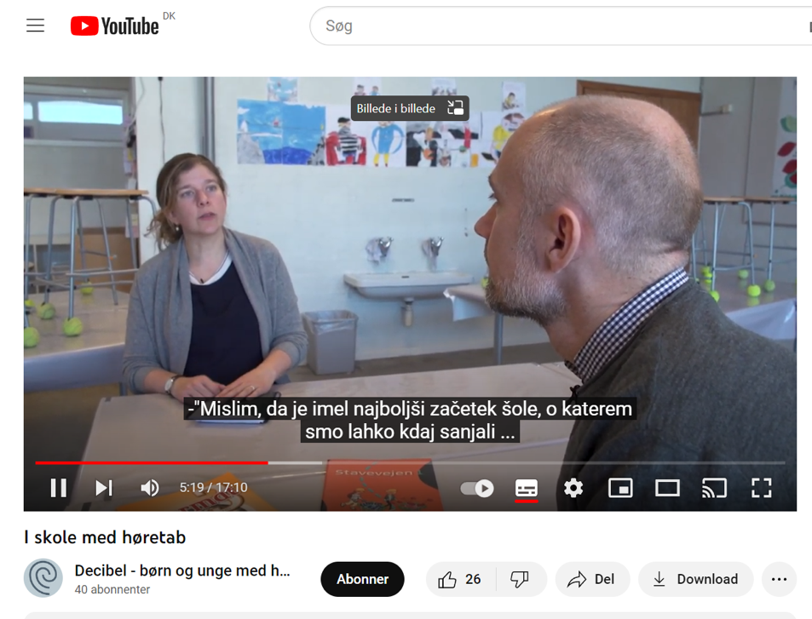
Danske undertekster:
Finish subtitles:
German subtitles:
Slovenian subtitles:

