Guide to an optimal classroom design

for hearing-impaired pupils

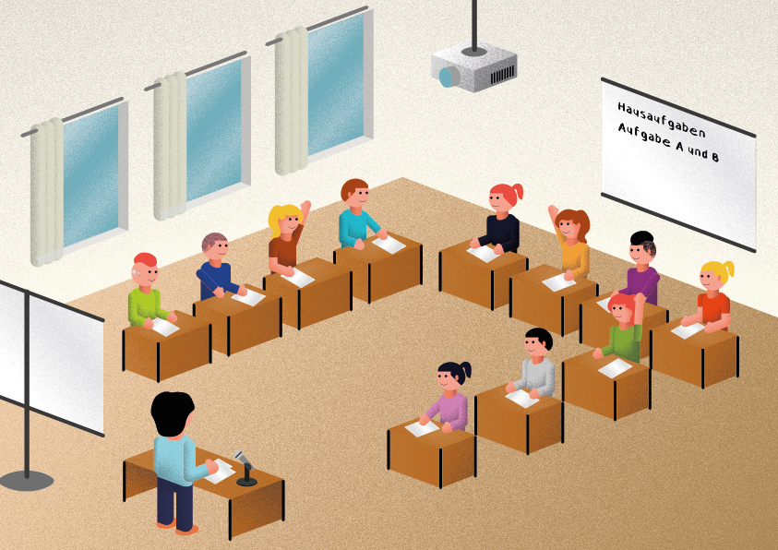

Teachers from the State Centre for Hearing and Communication
(Schleswig) have developed this guide and material.

For reasons of accessibility, all texts are written in simple language.


For further information, please contact
erasmus@lfzsl.de



Table of contents

Introduction 3
Manual 5
Checklist for teaching hearing-impaired pupils 6
The best classroom acoustics for hearing-impaired pupils 8
The best hearing technology for hearing-impaired pupils 14
The best seating arrangement for hearing-impaired pupils 19
The best lighting conditions for hearing-impaired pupils 23
Visualization in the teaching for hearing-impaired pupils 26
Interpreting services for hearing-impaired pupils 29
Evaluation 31
List of abbreviations 32

Introduction

Do you have a hearing-impaired pupil in your class?
Would you like to support him or her optimally in class?

Then proceed as described on the following pages.
The aim of this material is to inform teachers of hearing-impaired pupils in inclusive education about how to create optimal listening and learning situations in the classroom.
This includes room acoustics, hearing technology, seating, lighting conditions, visualisation in the classroom and interpreting services.
It would make sense if these optimisations could be made not only in the classroom, but also in other rooms, such as subject rooms, the gym, the refectory (by e.g. felt boards under the dining tables) and multi-purpose rooms. Attention should also be paid to optimal acoustics in the corridors, for example.

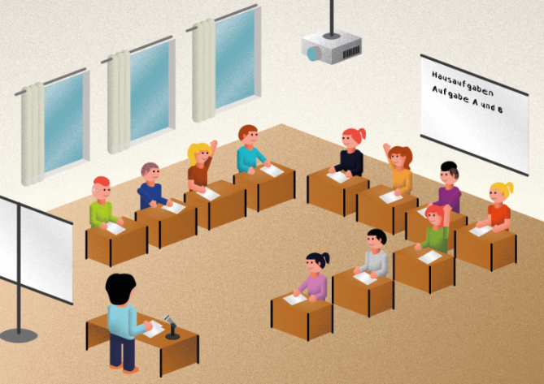




Checklist

Information texts

Changes

Evaluation of the changes

Topics:
room acoustics
hearing technology
seating arrangement
lighting
visualization
interpreting services

Manual

Review the situation in the classroom using the checklist.

Have you ticked any questions with “no” or “unknown”?
Please read the information on this topic.
There you will find possibilities for changes.

Change the situation for your hearing-impaired pupil.
Evaluate his situation once again.

Checklist for teaching hearing-impaired pupils

The best classroom acoustics for hearing-impaired pupils
Questions | yes | no | un-  known
Is the volume in the classroom less than 65 dB during silent work periods?
Is the reverberation time less than 0,45 seconds?
Are there acoustic ceilings made of sound-absorbing material?
Are there sound-absorbing wall panels or cork boards?
Are there carpets or sound-absorbing floor coverings?
Are there felt glides or tennis balls under chair legs on hard floors?
Are there open shelves?
Are there curtains?
Are there table pads?
Is there a quieter classroom?
Noises from outside cannot be heard, e.g. normal traffic noise, classmates in the schoolyard.
Noises from neighbouring classes cannot be heard.
Are the lights and heating system in the classroom quiet?
Is the media technology equipment quiet during use?

The best hearing technology for hearing-impaired pupils
Questions | yes | no | un-  known
Does the pupil wear his hearing aids or cochlear implants regularly?
Does the pupil take care that his personal hearing aids or cochlear implants are working (e.g. full batteries or charged rechargeable batteries)?
Is the teacher’s transmitter of the wireless transmission system working?
Are the receivers connected to the wireless transmission system?
Are the pupils’ microphones charged?
Are the pupils’ microphones working?
Are the pupils’ microphones connected to the wireless transmission system?
Are the pupils’ microphones switched on when speaking?
Is the loudspeaker of the soundfield amplification system switched on?
Are the pupils’ microphones in a fixed and safe place when not in use?

The best seating arrangement for hearing-impaired pupils
Questions | yes | no | un-  known
Is the hearing-impaired pupil seated in the front of the class?
Does the hearing-impaired pupil have a quiet neighbour?
Does the hearing-impaired pupil have sunlight at his back?
Can the hearing-impaired pupil see the teacher clearly?
Can the hearing-impaired pupil see all the other pupils well?

The best lighting conditions for hearing-impaired pupils
Questions | yes | no | un-  known
Is the light on?
Is the classroom evenly illuminated?
Is the classroom bright enough?
Is there an additional blackboard light that can be switched on?
The pupil sits in such a way that he is not dazzled.
Are the lamps evenly distributed on the ceiling?
Do the lamps give light without creating a shadow?
Is there light protection on the windows (curtains or blinds)?
Are the workplaces bright?
Does the lighting work properly?
Can the dimming of the lighting be actively influenced?

Visualization in the lessons of hearing-impaired pupils
Questions | yes | no | un-  known
Is the sequence of the lesson posted?
Are the topics written down?
Are difficult words and explanations written down?
Are all important informations (e.g. homework, dates and contents of class tests) written down?
Is there visualization technology in the classroom?
- Computer/ laptops/ tablets
- Document camera?
- Projector?
- Digital blackboard?
Are subtitles displayed for films?

Interpreting services for hearing-impaired pupils, who cannot follow the lessons well enough in terms of spoken language
Questions | yes | no | un-  known
Is there a stable internet connection in the school and classroom?
Does the teacher have a teacher transmitter?
Does the hearing-impaired pupil have a tablet or computer?
Can the hearing-impaired pupil use technology for his own purposes?
Can the hearing-impaired pupil read well enough to understand the texts of the written language interpreter?
Does the hearing-impaired pupil use or understand sign language
(signs to accompany spoken language, speech-supporting signs)?

The best classroom acoustics for hearing-impaired pupils

Poor acoustic conditions in classrooms are bad for learning. Good classroom acoustics are important so that the hearing-impaired pupil can understand well. The pupil should have little effort in listening and understanding. If the listening effort is too great, the hearing-impaired pupil will learn poorly. The pupil cannot concentrate on the subject matter. A prerequisite for good understanding in the room is a low reverberation time, good speech intelligibility, and a good useful sound – background sound ratio. Technical experts measure the acoustic conditions of a classroom with special measuring devices. Educators can use apps to measure acoustic conditions in the classroom.

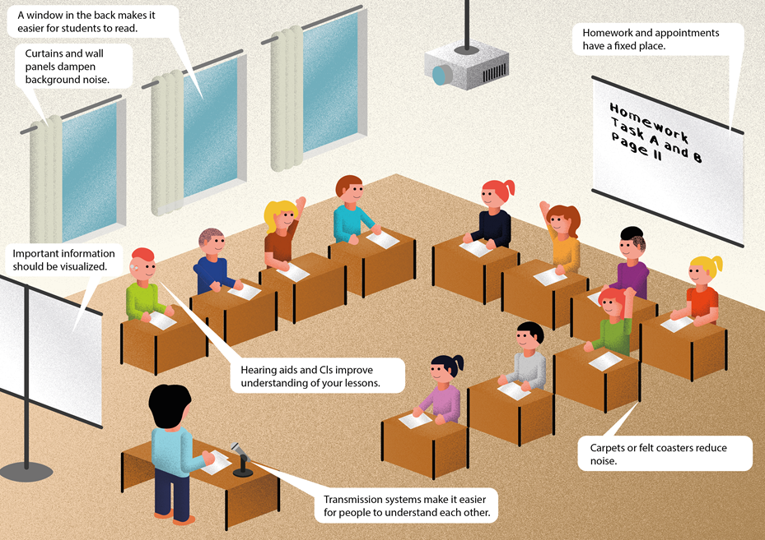

1. Classroom acoustics and acoustic conditions
In classrooms, a sound level is usually between 65dB and 75dB.
A sound level of 55dB is optimal for good learning conditions.
Room acoustics is the propagation of the sound in a room, in this case in the classroom. Sound propagates differently in space. It depends on the size and shape of the room and the materials in the classroom.

1.1 Reverberation time
Good room acoustics are achieved with a low reverberation time. There is a sound in the classroom. The ceiling, walls and furniture reflect the sound until it's gone. All sound reflections together are called reverberation. The reverberation time is the time from the creation of the sound to its disappearance. The reverberation time must be as short as possible. Many sound-insulating materials shorten the reverberation time. These materials are carpets, curtains, pillows, open shelves, ceilings made of acoustic material. The regulation says: In inclusive classrooms, the reverberation time must not be more than 0.45 sec. The abbreviation for reverberation time is RT. Measuring devices measure the time until the sound is 60 dB quieter. We are talking about RT60.
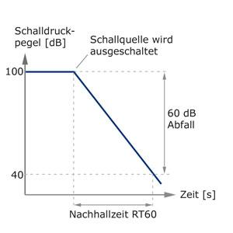

Classrooms with a reverberation time of 2 seconds are reverberant.
Note: The higher the reverberation time, the lower the understanding of speech in this classroom.
The reverberation becomes smaller the more sound-absorbing surfaces such as curtains, upholstered furniture, carpets or people are in the room. Suspended ceilings, open doors and windows also dampen the reverberation.

1.2 Speech intelligibility (Speech transmission Index: STI)
The intelligibility of spoken language in classrooms can be checked. The unit of measurement for speech intelligibility is the Speech Transmission Index (STI). Measuring speech intelligibility with a specific acoustic signal shows the intelligibility of the received signal at different measurement points.
It is shown in the table below.
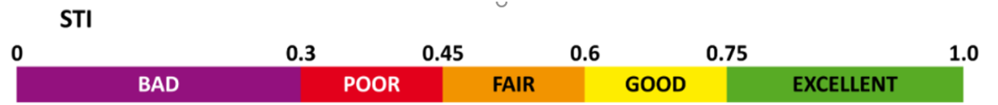

The sound pressure level, the background noise, the reverberation time and useful sound – background sound ratio influence speech intelligibility. This measurement is carried out by technical experts.

1.3 Improving speech intelligibility
Speech intelligibility is improved by optimizing room acoustics, avoiding background noise, and using certain teaching methods.
A high noise level in the classroom can be reduced by
- clear rules of conversation,
- use of "talking stones" (only those who have the stone in their hand may talk),
- have all materials ready before the lesson starts,
- writing down the material list at the beginning of the lesson,
- a learning clock shows the length of the working period,
- use quiet teaching materials: e.g. dices made of rubber and not plastic or wood

1.4 Useful sound
The useful signal of speech (S=speaker's voice), must be significantly higher than the interference signal (N=noise). The useful sound should be at least 15 dB louder than the background noise (S-N=15 dB). The useful sound, also direct sound, should reach the listener (= pupil) without reflections as quick as possible.

1.5 Noise and diffuse noise
Any background noise is noise. Noise interferes with communication. Noise makes it very difficult to understand speech. If the background noise is very loud, the hearing-impaired pupil cannot understand anything. Disturbing noises in everyday school life are external noises from open windows, road traffic, noises from next door due to poor insulation, domestic systems (heating, ventilation, air conditioning), media technology devices (projectors, computers), noises that come from pupils.
Diffuse sound is reflected multiple times off the walls until it reaches the listener (= pupil).

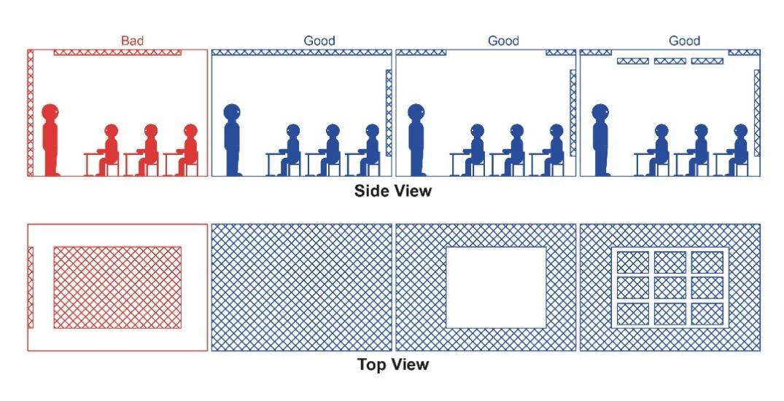

1.6 Location of the classroom
The room acoustics in the classroom need to be improved. Discuss the location of the room:
- Is it near a noisy street?
- Is the ambient noise particularly high here?

Preliminary considerations:
- Is there a classroom in the school that is more quiet?
- Is there a possibility to swap?

Measures to improve classroom acoustics
There are factors in the classroom design that may make noise quieter.
You can reduce the reverberation time by:
- acoustic suspended ceilings made of a sound-absorbing material
- Sound-absorbing wall panels or corkboards on the wall in the height range of the heads of sitting and standing people
- table pads
- open shelves
- curtains

You can reduce noise by:
- carpet or sound-absorbing rubber or linoleum floor coverings
- felt glides or tennis balls under chair legs on hard floors
- table pads for reflecting surfaces
- switching off media technology devices that are not required (e.g. projectors)
- low-noise building services systems
- soundproofing measures on windows and doors

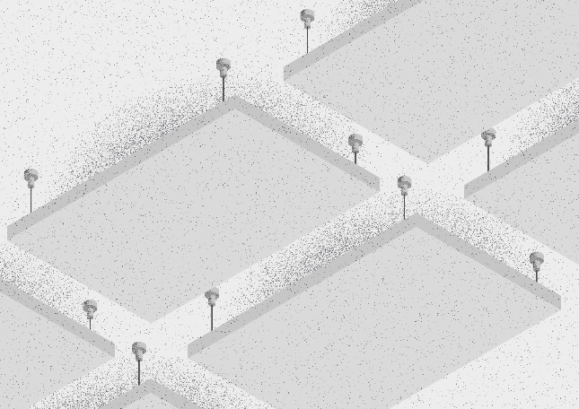

Checklist: The best classroom acoustics for hearing-impaired pupils
Is the volume in the room less than 65 dB during silent work periods?
Is the reverberation time less than 0.45 seconds?
Are there:
- acoustic ceilings made of a sound-absorbing material?
- sound-absorbing wall panels or corkboards?
- carpets or sound-absorbing floor coverings?
- felt glides or tennis balls under chair legs on hard floors?
- open shelves?
- curtains?
- table pads?
- Is there a quieter classroom?
- Noises from outside cannot be heard, e.g. normal traffic noise, classmates in the schoolyard.
- Noises from neighbouring classes cannot be heard.
- Are the lights and heating system in the classroom quiet?
- Is the media technology equipment quiet during use?

Apps:
myraumklang app
rockfon raumakustik app

References:
Deutsche Gesetzliche Unfallversicherung e.V. (DGUV) (Hrsg.) (2012, aktualisiert 2018): Klasse(n) – Räume für Schulen. DGUV Information 202-090

Jacobs, H., Schneider, M., Wisnet, M. (2004): Hören – Hörschädigung: Informationen und Unterrichtshilfen für allgemeine Schulen. Der Paritätische Wohlfahrtsverband, Landesverband Hessen

Landesverband Bayern der Schwerhörigen und Ertaubten e.V. (2019): Pro Inklusion 2/2019
Schneider O, Hennies J, Jäger S, Rauner R, Schäfer K, Schulz W, Stecher M (2021):
Leitlinien guter Unterricht. Arbeitskreis Unterricht, Berufsverband Deutscher Hörgeschädigtenpädagogen e. V. Online verfügbar unter www.bdh-guter-unterricht.de Last accessed: 27.06.2022

Truckenbrodt, T., Leonhardt, A. (2016): Schüler mit Hörschädigung im inklusiven Unterricht. München: Ernst Reinhardt Verlag

The best hearing technology for hearing-impaired pupils
Hearing technology includes all technical devices available to hearing-impaired people. This includes personal hearing aids and supplemental hearing systems. With these necessary aids, hearing-impaired pupils can follow what is going on in class more easily. This helps hearing-impaired pupils to better absorb and understand what is being taught.

1. Individual hearing aids
There are hearing aids and implantable hearing aids. The ear, nose and throat doctor diagnoses the child's hearing impairment and prescribes the appropriate technical hearing aid depending on the hearing loss. These hearing aids must be regularly maintained and checked. Batteries need to be changed or recharged regularly.

1.1 Hearing aids
Hearing aids help if the child is hard of hearing. The audiologist will fit the hearing aids.

1.1.1 Behind-the-ear (BTE) hearing aids

Hearing-impaired pupils usually wear BTE devices. The BTE hearing aid is worn behind the ear. The hearing aid amplifies sound and transmits it directly to the ear.

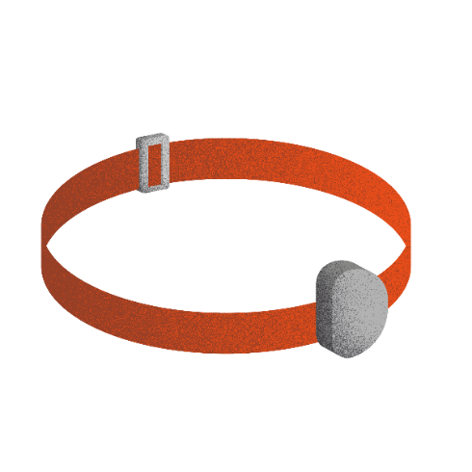
1.1.2 Bone conduction hearing aids
Bone conduction hearing aids are suitable for hearing-impaired pupils with damage to the outer or middle ear. The hearing device transmits sound via vibration to the bone behind the ear. Through the bone, the sound is sent directly to the inner ear. This allows the hearing-impaired pupil to hear. The bone conduction hearing aid is worn with a headband or attached to an adhesive adapter.

1.2 Implantable hearing systems
An implantable hearing system consists of several parts. The visible parts are worn on the outside of the head. Other parts are implanted. This hearing system helps people with profound hearing loss, with damage to the outer, middle or inner ear.

You can read more about hearing technology on Advanced bionics' website here (cochlear implants only).
You can read more about hearing technology on Cochlears website here.
You can read more about hearing technology on Medels website here.
You can read more about hearing technology on Sophonos website here.

1.2.1 Cochlear implant (CI)
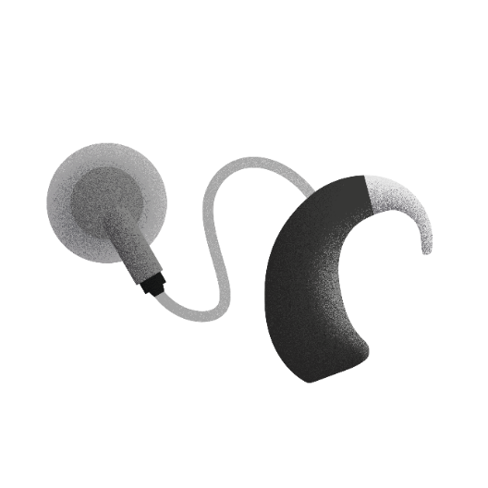
Cochlear implants help hearing-impaired pupils with profound hearing loss or hearing-impaired pupils who are profoundly deaf. The CI is made up of several components. The sound processor and the transmitter are visible on the outside. The implant is located under the skin behind the ear.
Cochlear implants (CI) and implantable hearing systems are implanted and fitted in CI centres or clinics.

1.2.2 Partially implantable hearing systems

Middle ear implant
The sound processor is located on the outside of the head. The implant is located in the middle ear and transmits sound to the inner ear. This allows the pupil to hear.

Bone conduction implant
The sound processor is located on the outside of the head. The implant is placed in the bone of the skull behind the ear. The implant transmits sound vibrations through the bones of the skull directly to the inner ear. This allows the pupil to hear.

2. Additional hearing systems
For hearing aids and implants, there are additional hearing systems: individual hearing transmission systems, classroom sound systems and pupil microphones. Additional hearing systems optimise listening in a noisy environment or when the speaker is at a distance. Hearing systems need to be powered or charged.

2.1 Hearing transmission system and pupil microphones
The hearing transmission system consists of a microphone for the teacher and additional microphones for pupils. The system is connected to the receivers on the hearing aid or implant.
The wireless microphones (one microphone for the teacher and separate pupil microphones) transmit the voice of the speaker directly to the receivers of the hearing aid or implant. In this way, the hearing-impaired pupil can understand speech well without background noise, as well as speech over distance.
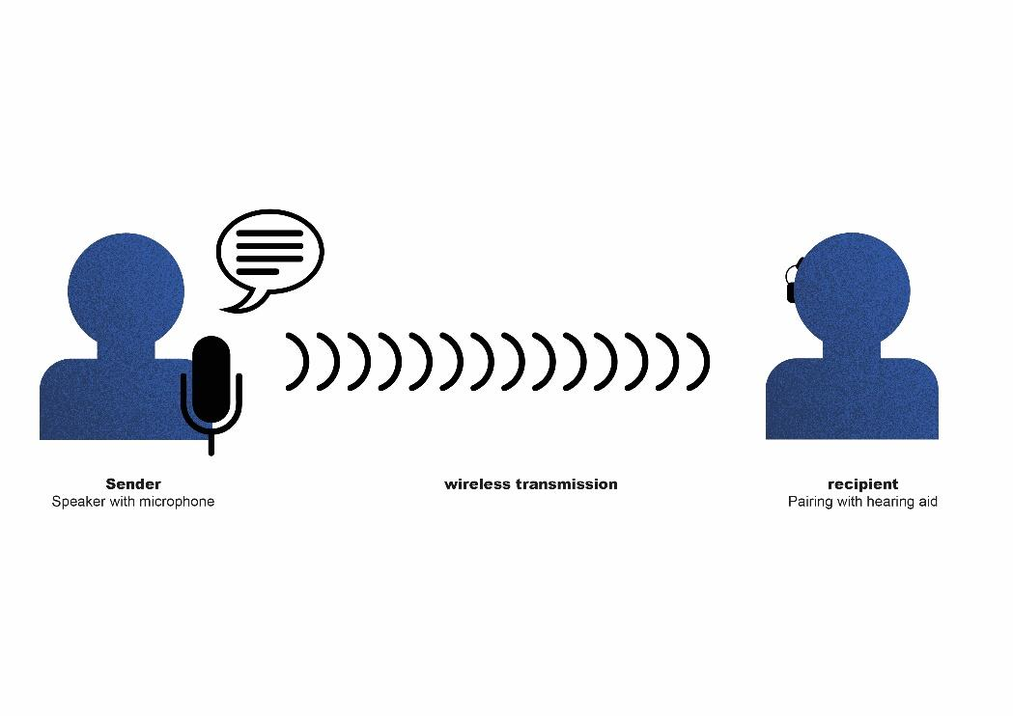
A multimedia hub connects the wireless transmission system to:
- PC, tablet
- Smartboard, TV
- MP3 player
Read more about wireless transmission systems on Phonaks website.

The following film shows how a hearing-impaired pupil hears in noise without and with the help of a digital transmission system and pupil microphones:

2.2 Classroom sound system / Soundfield system
The wireless soundfield amplification system improves the acoustic conditions for teachers and all pupils in the classroom. The microphone picks up the voice of the speaker and sends the speech to the loudspeaker. The loudspeaker spreads the speech evenly throughout the classroom. This way, everyone in the classroom can understand well, regardless of where they are seated.

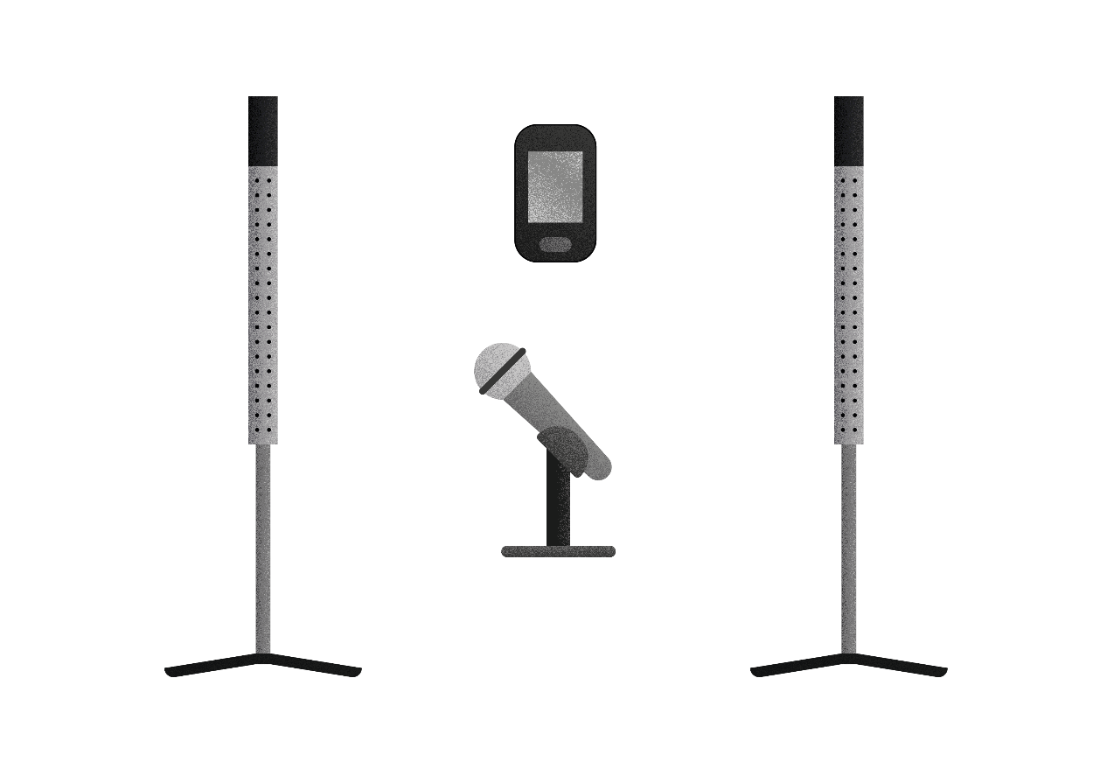

Checklist:The best hearing technology for hearing-impaired pupils
Does the pupil wear his hearing aids or cochlear implants regularly?
Does the pupil take care that his personal hearing aids or cochlear implants are working (e.g. full batteries or charged rechargeable batteries)?
Is the teacher’s transmitter of the wireless transmission system working?
Are the receivers connected to the wireless transmission system?
Are the pupils’ microphones charged?
Are the pupils’ microphones working?
Are the pupils’ microphones connected to the wireless transmission system?
Are the pupils’ microphones switched on when speaking?
Is the loudspeaker of the soundfield amplification system switched on?
Are the pupils’ microphones in a fixed and safe place when not in use?

References:
Schneider O, Hennies J, Jäger S, Rauner R, Schäfer K, Schulz W, Stecher M (2021).
Leitlinien guter Unterricht. Arbeitskreis Unterricht, Berufsverband Deutscher Hörgeschädigtenpädagogen e. V. Available online at: www.bdh-guter-unterricht.de Last accessed: 12.03.2023

View Medels website her. Last accessed: 12.03.2023

View Phonaks website here. Last accessed: 12.03.2023

Watch a film about additional hearing systems here.
Last accessed: 12.03.2023

Beratungslehrkräfte des Landesförderzentrums Hören und Kommunikation, Schleswig (2022): Hörgeschädigte Kinder und Jugendliche, Informationen für Eltern und Lehrkräfte. Informationsbroschüre.

The best seating arrangement for hearing-impaired pupils
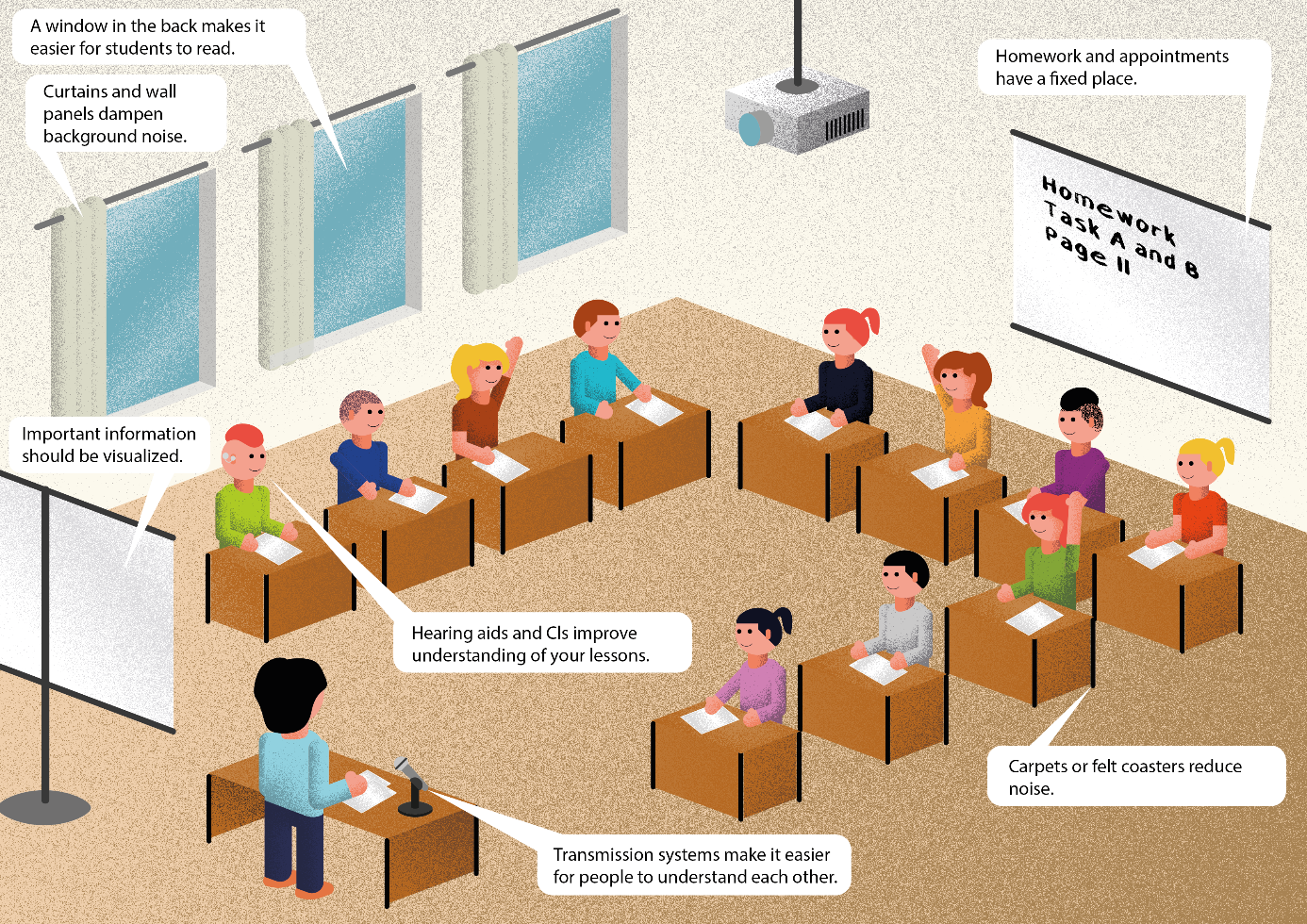

1. Seating arrangement
The seating arrangement should fit the class size, the room size and the teaching style.
It is best for the class to sit in a U-shape or in a semicircle (see illustration). Then the hearing impaired pupil can see everyone well.

2. Seat

2.1 Distance
The hearing impaired pupil sits 1-2 m away from the teacher.
Why? The further the distance, the harder it is to understand the teacher's voice.
Principle: 1 m distance makes the teacher's voice 6 dB quieter. This is measurable.
2 m makes the voice 12 dB softer. After 3 m, the voice is already 18 dB quieter.

2.2 Useful sound
The useful sound (= teacher's voice) should always be 6dB louder than the background noise.

2.3 Background noise
All ambient noise is background noise. Background noise disturbs communication. Background noise makes it very difficult to understand speech. If the background noise is very loud, the hearing-impaired pupil cannot understand anything.

2.4 Seat neighbour
A quiet seatmate can be a good buddy for the hearing-impaired pupil. For example, the buddy can help to think about technology.

2.5 Seating for pupils with one-sided hearing impairment
When there is noise, a unilaterally hearing-impaired pupil may have difficulty understanding speech.
If there is background noise, he has to concentrate very hard.
Often the hearing-impaired pupil does not understand speech when spoken to in the hearing-impaired ear.
It is then more difficult for him to understand a conversation.
The unilaterally hearing-impaired pupil sits with the good hearing ear facing the teacher.
A swivel chair helps the hearing-impaired pupil to turn quickly towards his classmates. This way he can also hear their answers well.

3. Enable lip reading

3.1 Eye contact
The hearing-impaired pupil can see the faces of teachers and classmates.
This enables him to recognise the mouth image and the different facial expressions well.

3.2 Sunlight
The hearing-impaired pupil sits with his back to the window.
Then he does not have to look against the sunlight and is not blinded.

4. Different learning (didactics and methodology)
The seat of a hearing-impaired pupil depends on the form of learning in class.
The following points are important:
- Proximity to the teacher
- Little or no disturbing noise
- A quiet neighbour can be helpful
- Eye contact is possible
- The light is not blinding
The hearing-impaired pupil sits in such a way that all the above points apply.

Sometimes there are group tables in the classroom. A seating semicircle in front of the blackboard is good for class discussions and presentations. This way everyone can see each other well.

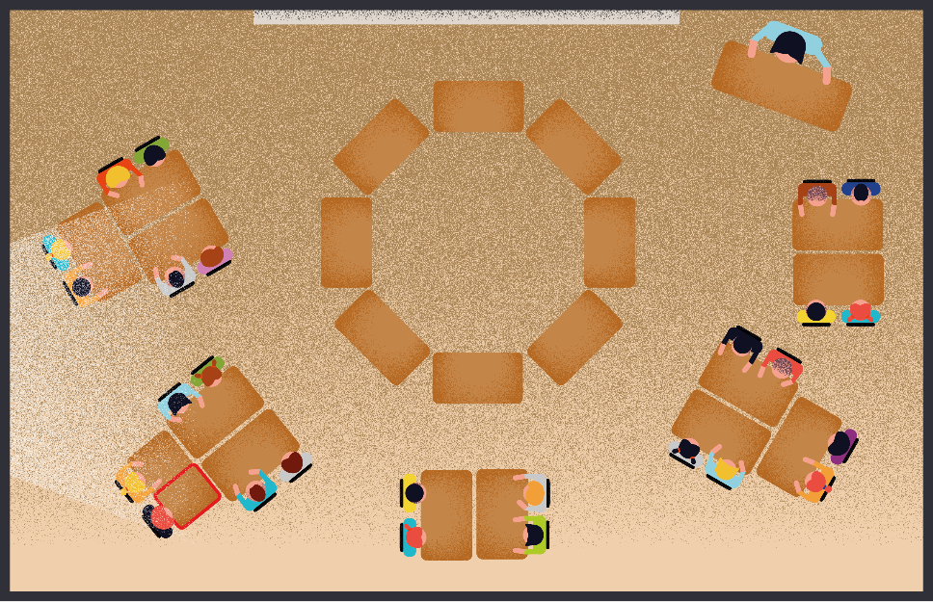

4.1 Frontal teaching
The teacher teaches from the front. There is little pupil interaction.
The desks are in a U-shape or in a semicircle.
The hearing-impaired pupil sits in the U-shape in the front and in the semicircle in the
middle.
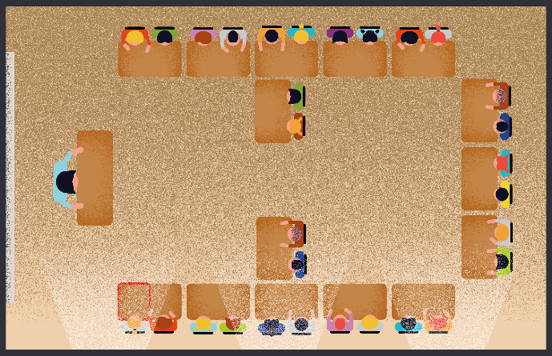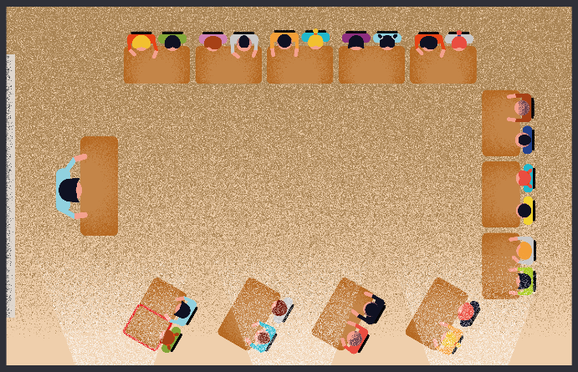

4.2 Open form of teaching
Pupils work alone, with a partner or in a group.
The hearing impaired pupil sits in a quiet place in the class.
The work material for all pupils is far away from the hearing impaired pupil. Then the other pupils do not disturb the hearing-impaired pupil when they fetch material.
In partner work, the hearing-impaired pupil sits opposite the partner. The pupils can look at each other.
For group work, the group sits with the hearing-impaired pupil in another room.

Checklist:The best seating arrangement for hearing-impaired pupils
Is the hearing-impaired pupil seated at the front of the class?
Does the hearing-impaired pupil have a quiet neighbour?
Does the hearing-impaired pupil have sunlight at his back?
Can the hearing-impaired pupil see the teacher clearly?
Can the hearing-impaired pupil see all the other pupils well?

References:
Reich, K. (Hg.): Methodenpool. In: url: http://methodenpool.uni-koeln.de
Last accessed: 27.06.2022

Schneider O, Hennies J, Jäger S, Rauner R, Schäfer K, Schulz W, Stecher M (2021):
Leitlinien guter Unterricht. Arbeitskreis Unterricht, Berufsverband Deutscher Hörgeschädigtenpädagogen e. V. Online verfügbar unter www.bdh-guter-unterricht.de Last accessed: 27.06.2022
Truckenbrodt, T., Leonhardt, A. (2016): Schüler mit Hörschädigung im inklusiven Unterricht. München: Ernst Reinhardt Verlag

The best lighting conditions for hearing-impaired pupils
Good lighting conditions in the classroom are especially important for hearing-impaired pupils.
Hearing-impaired pupils need good light to be able to see the speaker's mouth image, the blackboard and other illustrations well. Vision provides additional information. In poor light, the eyes tire quickly and concentration wanes. Artificial lighting creates uniformly good visual conditions.

1. Good light:
- Increases stamina and concentration
- Improves visual acuity and detail recognition
- Increases reading speed
- Increases contrast perception
- Improves communication

2. Good room lighting means:
- The lighting in the room is uniform.
- The light intensity can be regulated.
- The light does not dazzle.
- The windows have light protection (curtains and blinds).
- The workplaces are bright.
- The lamps do not produce shadows.
- The lighting does not flicker.
- The lighting is dimmable.

2.1 Illuminance and luminance distribution
(Illuminance and luminance distribution refers to the number and arrangement of lamps in a room).
Illuminance is measured in lux. In the classroom, the illuminance should be at least 500 lux everywhere.
It is possible to check this with a mobile phone app.
The lighting in the room must be evenly distributed.

2.2 Glare limitation and lighting direction
Pupils must not be dazzled.
Light must not reflect, reflect or produce shadows.
We need:
- matt surfaces
- Internal or external blinds
- An arrangement of lamps parallel to the window
- Lamps that do not produce shadows
- Lamps with indirect light
- The windows have light protection (curtains and blinds)
- The workplaces are bright.
- The lamps do not produce shadows.
- The lighting does not flicker.
- The lighting is dimmable.

2.3 Light colour
The light colour must be the same throughout the room. It is perceived differently by everyone. There is no regulation.

Checklist: The best lighting conditions for hearing-impaired pupils
Is the light on?
Is the classroom evenly illuminated?
Is the classroom bright enough?
Is there an additional blackboard light that can be switched on?
The pupil sits in such a way that he is not dazzled.
Are the lamps evenly distributed on the ceiling?
Do the lamps give light without creating a shadow?
Is there a light protection on the windows (curtains or blinds)?
Are the workplaces bright?
Does the lighting work properly?
Can the dimming of the lighting be actively influenced?

Apps:
Lichtmesser LM-3000
Lux Meter for professional

References:
Deutsche Gesetzliche Unfallversicherung e.V. (DGUV) (Hrsg.) (2012, aktualisiert 2018): Klasse(n) – Räume für Schulen. DGUV Information 202-090
Hase, U. (Hrsg): Barrierefreiheit durch gutes Licht

Röpke, B.: Lichtberatung: Verbesserung der Rahmenbedingungen durch künstliche Beleuchtung. Landesförderzentrum Sehen, Schleswig

Schneider O, Hennies J, Jäger S, Rauner R, Schäfer K, Schulz W, Stecher M (2021):
Leitlinien guter Unterricht. Arbeitskreis Unterricht, Berufsverband Deutscher Hörgeschädigtenpädagogen e. V. Online verfügbar unter www.bdh-guter-unterricht.de
Last accessed: 27.06.2022

Visualization in the teaching of hearing-impaired pupils

1. What does visualization mean?
Visualization means the illustration of certain facts.

2. Why is visualization important?
A hearing-impaired pupil does not understand everything that is said in class. Seeing pictures and reading information helps the pupil to understand. The teacher should write as much as possible. The hearing-impaired pupil must therefore be able to see the blackboard well.

3. What is visualized?
The teacher writes as much as possible.
This includes:
- themes and sequence of the lesson
- difficult words with explanation
- homework
- contents and deadlines for class tests
The teacher shows many pictures, diagrams and films.
In the case of films, he switches on the subtitles for reading along.
The classmate gives the hearing-impaired pupil a handout for a presentation or lecture. The pupil can read along.
These measures enable the hearing-impaired pupil to understand better during lessons.
The pupil does not have to do as much revision at home.
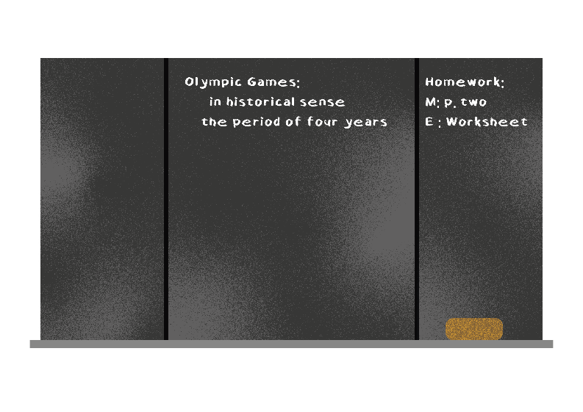

4. Technical equipment for visualization

4.1 Visualization equipment
In the classrooms there are various technical devices for visualization. On the teacher's side, these include PCs, projectors, digital boards and document cameras.
Pupils have laptops, notebooks and tablets.
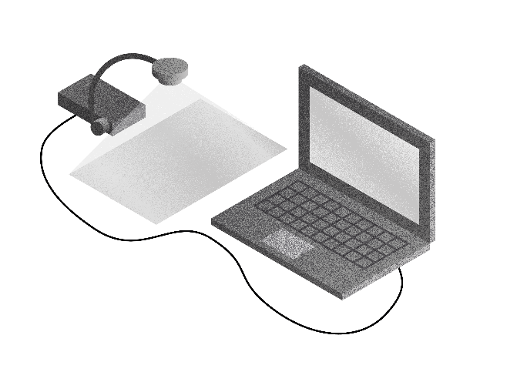

4.2 Possible uses
The teacher uses technology to illustrate content, texts and tasks.
Pupils show their work results via the wireless connection of their own computer to the digital board. In this way, the pupils can read all work results.
Blackboard pictures can be saved or sent.
Many films on various topics are available on the Internet for teaching purposes.
Subtitles help the hearing-impaired pupil to understand the content.
The hearing-impaired pupil can connect his hearing aids or CIs to the digital board via Bluetooth or the digital transmission system.
In this way, the hearing-impaired pupil can follow films without interference.
Digitalization helps the hearing impaired pupil a lot in class.

5. Prerequisites
For digitalization, schools need good infrastructure.
This includes:
- A good, reliable electricity network
- Own Wi-Fi
- A sufficient number of digital end devices
- Knowledge of the use and application of the end devices on the part of the pupils and teachers
- IT administrators at each school

Checklist: Visualization in the lessons of hearing-impaired pupils.
Is the sequence of the lesson posted?
Are the topics written down?
Are difficult words and explanations written down?
Are all important informations (e.g. homework, dates and contents of class tests) written down?
Is there visualization technology in the school?
- Computers/ laptops/ tablets?
- Document camera?
- Projector?
- Digital blackboard?
Are subtitles displayed for films?

References:
Digitalmagazin, Digitalisierung in Schule und Ausbildung: wie sich der Nachwuchs auf die Industrie 4.0 vorbereitet (Online article available here).

Schneider O, Hennies J, Jäger S, Rauner R, Schäfer K, Schulz W, Stecher M (2021):
Leitlinien guter Unterricht. Arbeitskreis Unterricht, Berufsverband Deutscher Hörgeschädigtenpädagogen e. V. Available online at: www.bdh-guter-unterricht.de
Last accessed: 27.06.2022

Truckenbrodt, T., Leonhardt, A. (2016): Schüler mit Hörschädigung im inklusiven Unterricht. München: Ernst Reinhardt Verlag

Wikipedia: Visualization disambiguation, last edited on 19.04.2021

Interpreting services for hearing-impaired pupils

1. Interpreting services
Various interpreting services are available to support hearing-impaired pupils in the classroom.
There are on-site sign language interpreters, speech-to-text reporters and digital software to convert spoken language into text.

1.1 Sign language interpreters
Sign language interpreters translate spoken language into sign language on site.

1.2 Remote interpreting services
With remote interpreting, the interpreter is not in the room but is connected online. The interpreter writes down spoken language or translates into sign language. The hearing-impaired pupil is connected to the interpreter via computer, tablet or mobile phone. Remote interpreting is independent of location.

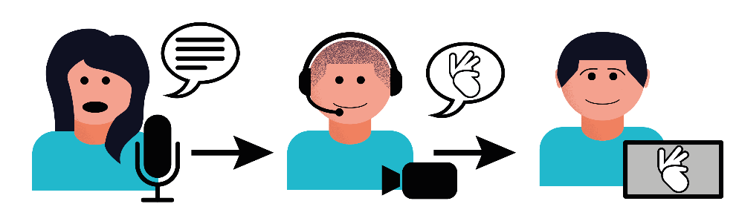

1.2.1 Speech-to-text reporters
In written language interpreting, the teacher is digitally connected to the remote interpreter. The speech-to-text reporter writes down what is heard and sends it digitally to the hearing-impaired pupil. In this way, the hearing-impaired pupil can read the text and knows what the teacher is saying. The pupil can read the text and ask questions in the chat. Speech-to-text reporters can interpret in different languages.

1.2.2 Sign language interpreter
The pupil sees the interpreter via video on the computer, tablet or mobile phone. This interpreter is called a sign language interpreter.
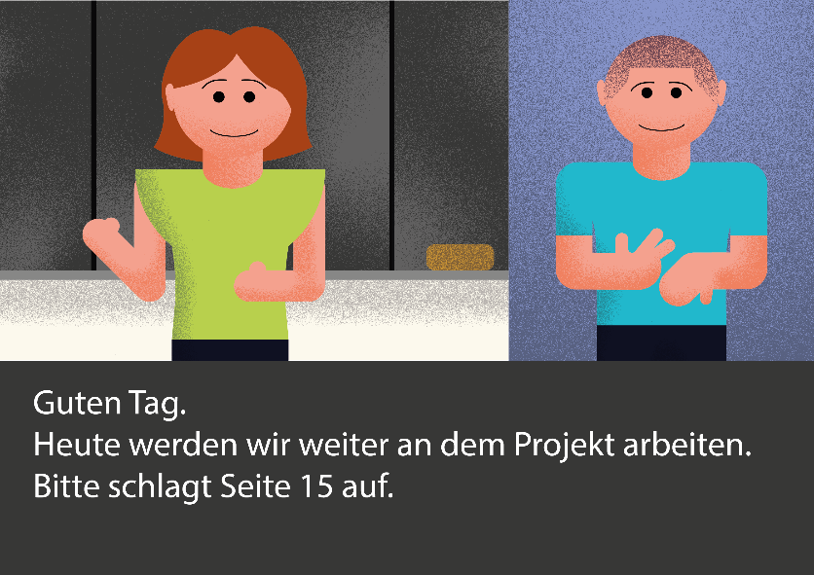
Hello.
Today we will continue to work on the project.
Please open page 15.

1.3 Converting spoken language into text using computer software
Computer software can be used immediately and costs less money than interpreting services. Different languages can be selected. There are different platforms for this.

2. Requirements
For remote interpreting services, schools need a good, reliable electricity network and their own Wi-Fi.
The teacher needs a microphone that can be connected to a digital device.
The hearing-impaired pupil can read or use sign language.
The pupil has a digital terminal and is familiar with the technology.

Checklist: Interpreting services for hearing-impaired pupils
Is there a stable internet connection in the school and classroom?
Does the teacher have a teacher transmitter?
Does the hearing-impaired pupil have a tablet or computer?
Can the hearing-impaired pupil use the technology for his own purposes?
Can the hearing-impaired pupil read well enough to understand the texts of the
written language interpreter?
Does the hearing-impaired pupil use and understand sign language (signs to accompany spoken language, speech-supporting signs)?

References:
View VerbaVoices website her. Last accessed: 12.11.2025

Evaluation

Have changes been made? O Yes O No

Changes have been made in the topic
a. room acoustics O Yes O No
b. hearing technology O Yes O No
c. the seating O Yes O No
d. visualization O Yes O No
e. lighting O Yes O No
f. interpreting services O Yes O No

Has the change improved the
a. participation? O Yes O No
b. attention? O Yes O No

The following is planned or will be applied for (e.g. room acoustic measures, felt gliders...):
____________________________________________________________________________________
____________________________________________________________________________________
____________________________________________________________________________________

List of abbreviations

C
CI Cochlear Implant (implantable hearing aid in the cochlea)

D
dB decibel (unit of measurement for measuring volume)

L
Lux unit of measurement for measuring luminous intensity

R
RT engl. Reverberation Time (unit of measurement for reverberation time)

S
S useful signal for measuring speech
s second
STI engl. Speech Transmission Index (unit of measurement for speech intelligibility)

