Visualization in the teaching of hearing-impaired pupils

1. What does visualization mean?
Visualization means the illustration of certain facts.

2. Why is visualization important?
A hearing-impaired pupil does not understand everything that is said in class. Seeing pictures and reading information helps the pupil to understand. The teacher should write as much as possible. The hearing-impaired pupil must therefore be able to see the blackboard well.

3. What is visualized?
The teacher writes as much as possible.
This includes:
- themes and sequence of the lesson
- difficult words with explanation
- homework
- contents and deadlines for class tests
The teacher shows many pictures, diagrams and films.
In the case of films, he switches on the subtitles for reading along.
The classmate gives the hearing-impaired pupil a handout for a presentation or lecture. The pupil can read along.
These measures enable the hearing-impaired pupil to understand better during lessons.
The pupil does not have to do as much revision at home.
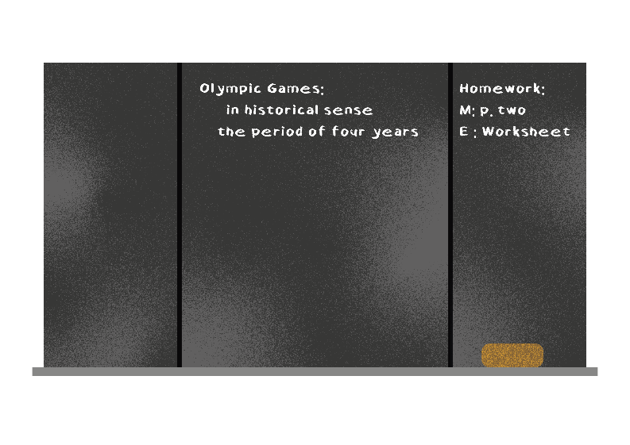

4. Technical equipment for visualization

4.1 Visualization equipment
In the classrooms there are various technical devices for visualization. On the teacher's side, these include PCs, projectors, digital boards and document cameras.
Pupils have laptops, notebooks and tablets.
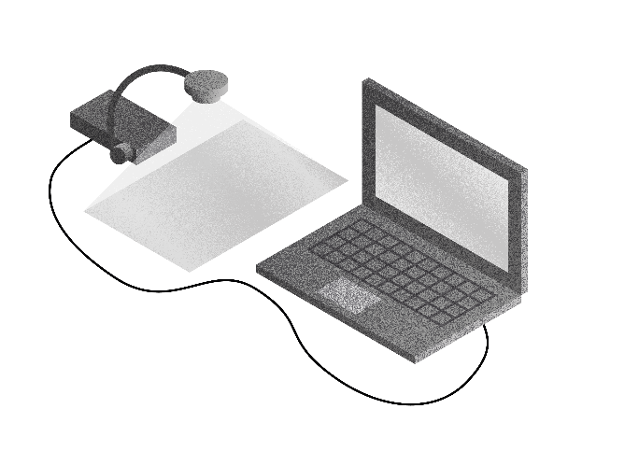

4.2 Possible uses
The teacher uses technology to illustrate content, texts and tasks.
Pupils show their work results via the wireless connection of their own computer to the digital board. In this way, the pupils can read all work results.
Blackboard pictures can be saved or sent.
Many films on various topics are available on the Internet for teaching purposes.
Subtitles help the hearing-impaired pupil to understand the content.
The hearing-impaired pupil can connect his hearing aids or CIs to the digital board via Bluetooth or the digital transmission system.
In this way, the hearing-impaired pupil can follow films without interference.
Digitalization helps the hearing impaired pupil a lot in class.

5. Prerequisites
For digitalization, schools need good infrastructure.
This includes:
- A good, reliable electricity network
- Own Wi-Fi
- A sufficient number of digital end devices
- Knowledge of the use and application of the end devices on the part of the pupils and teachers
- IT administrators at each school

Checklist: Visualization in the lessons of hearing-impaired pupils.
Is the sequence of the lesson posted?
Are the topics written down?
Are difficult words and explanations written down?
Are all important informations (e.g. homework, dates and contents of class tests) written down?
Is there visualization technology in the school?
- Computers/ laptops/ tablets?
- Document camera?
- Projector?
- Digital blackboard?
Are subtitles displayed for films?

References:
Digitalmagazin, Digitalisierung in Schule und Ausbildung: wie sich der Nachwuchs auf die Industrie 4.0 vorbereitet (Online article available here).

Schneider O, Hennies J, Jäger S, Rauner R, Schäfer K, Schulz W, Stecher M (2021):
Leitlinien guter Unterricht. Arbeitskreis Unterricht, Berufsverband Deutscher Hörgeschädigtenpädagogen e. V. Available online at: www.bdh-guter-unterricht.de
Last accessed: 27.06.2022

Truckenbrodt, T., Leonhardt, A. (2016): Schüler mit Hörschädigung im inklusiven Unterricht. München: Ernst Reinhardt Verlag

Wikipedia: Visualization disambiguation, last edited on 19.04.2021

