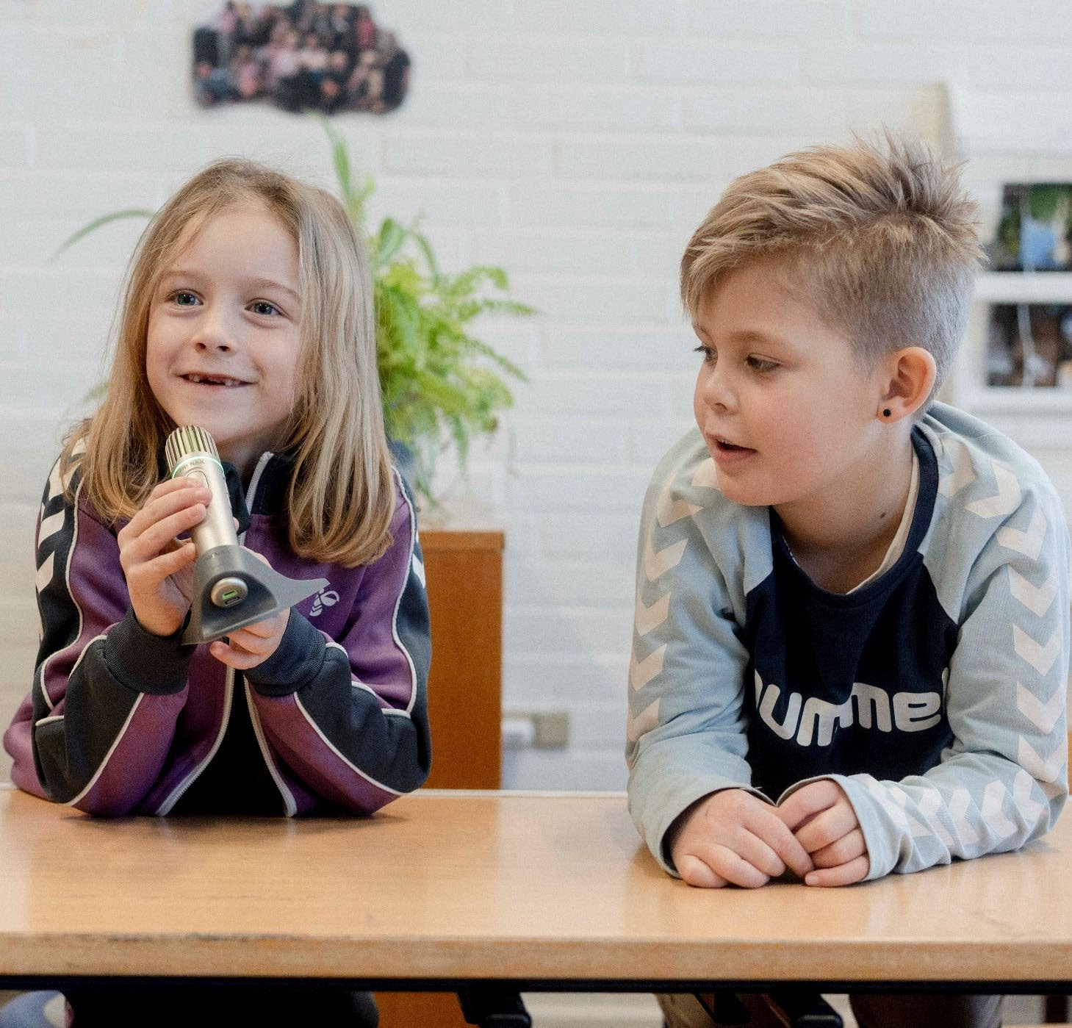
Additional information for the e-learning course

Information, resources, materials TRAP UP
Foto: Oscar Scott Carl

1

What have other learners said about this e-learning course?

The knowledge gained from the course is important for teaching all children, even those who do not have a hearing impairment, as everyone benefits from it.

2
German teacher at a mainstream school
Has the course led you to make different demands of your pupil?
Yes. Previously I might have repeated words or questions too quickly and tried to please the pupil immediately. Now I wait and always ask him what he has heard, and then I complete or repeat what is necessary. I have noticed that most of the time he is able to repeat what he has heard very well.
Slovenian teacher, mainstream school
I like to do this auditory before the visual, and the visual is added. I realise, that it doesn't make sense to a hearing- impaired person if she only reads the word. That was good.
Paying special attention to emphasising certain syllables or small words that are often swallowed, like "of" or "on" - that wasn't really new, but it was making me pay special attention to that.
German English-teacher, mainstream school

More testimonials

I can also see a great advantage in this course being taken by the individual teacher together with the local speech and hearing consultant. It would provide an excellent basis for good concrete discussions.

3
Danish local Speech, language and hearing Consultant

But with the last video, where it talked about, that it can be difficult for a hearing impaired student to give his own turn or continue discussion forward. Maybe I've noticed that my student listens to other students, but to a large extent still talks and takes his own case forward. He talks a lot about his own things.
Finnish teacher, mainstream school

It was giving new insights for me and now I know better how I can help my pupil in social inclusion. I got very good tips. Now I tried also to teach my pupil to ask for repetition, if he hasn’t heard or understood.
Finnish teacher, mainstream school

Raising awareness of hearing and behaviour: Conspicuous behaviour can be attributed to hearing loss and this can be an explanation for certain behaviours.
German teacher

What is a ‘Hearing professional’?

4

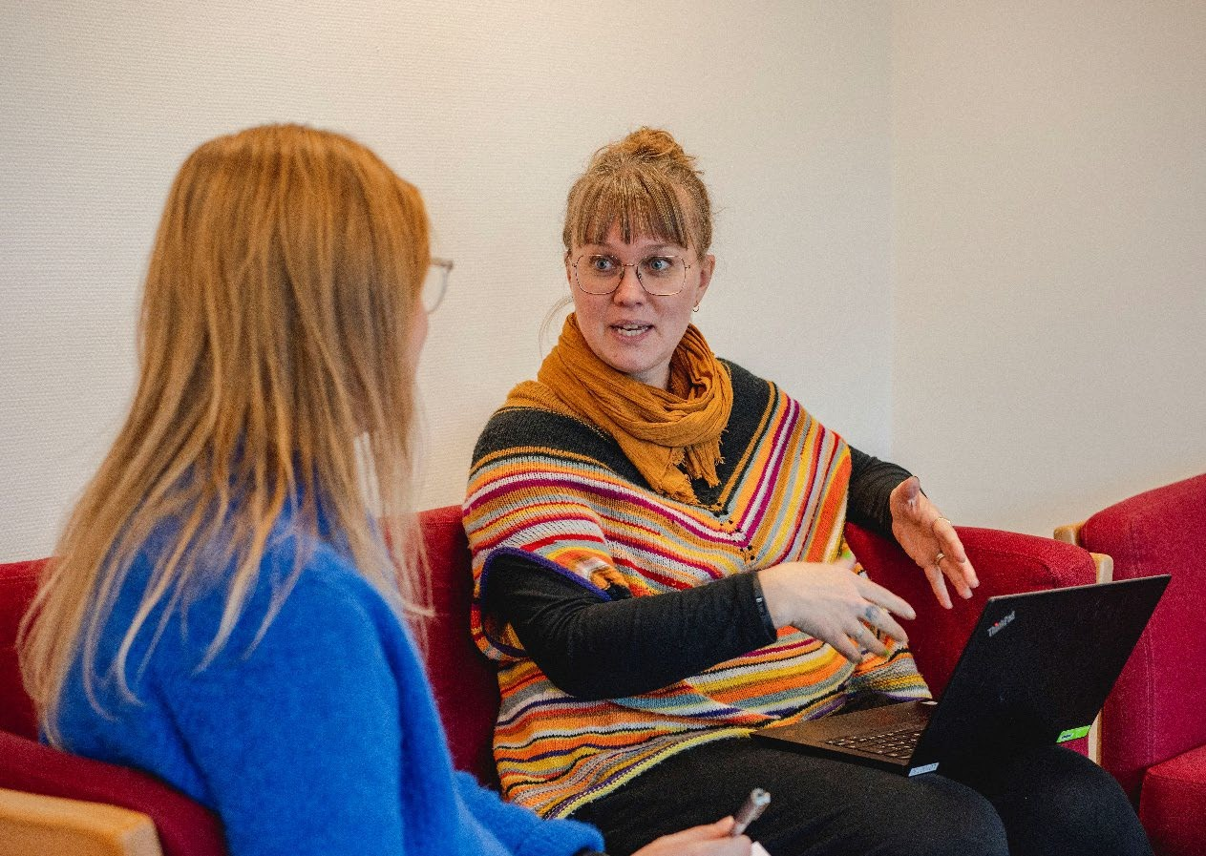
- A person with advanced knowledge about hearing loss in children and young people.
Foto: Oscar Scott Carl
- A background as a ‘speech-, language and hearing therapist’ with further specialisation or a ‘teacher of pupils with hearing loss’.
- Note, that each country has organised the services of this profession in different ways.
- A person who will discuss and advise about the individual needs of each pupil.
- A person to contact if the skills mentioned in the course are not met by the pupil.

Auditory or visual skills as the foundation


The model in the video of auditory skills as a precondition for the development of cognitive and language skills is based on children who communicate in a spoken language.
Learning and social skills
Cognitive skills
Language skills
For children who grow up in sign language speaking homes or who are taught sign language as their first language, visual skills will be the basis for the development of the same skills.
Auditory / visual skills

5

Pre-verbal communication

There are more fundamental themes in the life of a baby and young child that are essential for the general development of cognition, social interaction, communication and language of the child.

- The child’s early bonding with parents / caretakers
- Non-verbal early communication between child and adult, including eye contact, gaze, pointing, tactile (touching).
- Shared attention.
- Concentration and endurance.

A hearing loss may affect all these factors in early communication.

6







Auditory skills Listening skill

Auditory memory

Discrimi- nation in noise

What are auditory skills?
Auditory attention

Localize sound (directional hearing)

Discrimination of speech
7
7

More information about auditory skills

‘Phonological representation’ is also called ‘the sound of the word’.
The child may have heard and stored the word incorrectly in the first place, and therefore will not be able to spell this word correctly.
Pupils with asymmetrical hearing have problems localising sounds. Localising a sound or somebody talking can be a challenge.
For pupils with deaf parents speaking sign language, school is important to acquire and develop auditory skills in hearing surroundings. The auditory skills are the base for learning phonological awareness and literacy in school.

8

More auditory strategies in the classroom

Auditory strategies to help the pupil with hearing loss develop their auditory skills
and language:

- Expanding – repeat and expand the pupil’s utterance with a longer sentence or new words in a better version.

9

- Sabotage – do or say something crazy or unexpected or “forget” necessary items to accomplish an assignment. This will catch the auditory attention of the pupil and their wish to participate in a conversation and to use language more actively.
- Give choices – “Do you want the ruler or the eraser?” – when learning new concepts and words. Use this if the child is not able to answer an open question.
- Optimal positioning – Stand close to the hearing device (hearing aid, cochlear implant), especially in a noisy environment.
- Whispering – is used to catch the pupil’s attention. It is relevant when using Hearing Assistive Technology. It highlights unvoiced sounds like /f, s, h, sh, th, t, p, k/.

Chunking

10

  - “Chunking” is the process of grouping different bits of information together into more manageable or meaningful chunks. Do that and you make information clearer and easier to remember for yourself and others. Ref: Mindtools.com

  - Children with hearing loss may have a reduced auditory working memory and are not able to remember all items in a sentence.

  - Chunks are used for teaching a 2nd language as an ‘idiom’ that is frequent and can be repeated in many contexts. Examples: “How are you?”, “Can I have…”, “go for a walk”, “nice weather”….

Chunking
- Chunking is used for remembering numbers and lists of words, for example, a credit card number is chunked into groups of four: 3692 6902 …., a shopping list can be chunked into groups by type of items (fruit, dry food, beverages).

  - When teaching: Keep utterances short, pause briefly and start a new utterance each time you want to make a new point.

  - Learning the English forms of “to be”: Divide the forms into singular and plural and add rhythm to the phrase: “I am, you are, he/she/it is…. We are, you are, they are.”

  - Read more about chunking on mindtools.com.

11

‘Auditory before visual’ strategy

12

Use this strategy to keep the pupil listening and to learn new words.
When to use it:
    - When writing the agenda of the day on the board during the lesson.
    - When writing the agenda of the lesson on the board during the lesson.
    - Explaining new words and concepts – at the board or individually to the pupil: Describe the new word with descriptions, synonyms and examples orally first, and THEN write or show the word in its written form.
    - First talk with the pupil about the assignment from last time, then talk about the new assignment, and finally show it.
“Last time we learned about adding up to 10. Today we will learn about adding up to 20. This is how we will do it” (show it).

What is self-advocacy?

  - Self-advocacy is the ability to speak- up for yourself and the things that are important to you. Self-advocacy means you are able to ask for what you need and want and tell people about your thoughts and feelings.

  - Self-advocacy means you know your rights and responsibilities, you speak- up for your rights, and you are able to make choices and decisions that affect your life.
- The goal of self-advocacy is for you to decide what you want, and then develop and carry out a plan to help you get it.

- It does not mean you can’t get help if you need or want it, it just means that you are making the choices and you have to be responsible for the choices you make.
  - On this website you can read about self-advocacy.

13

Collaboration regarding the pupil

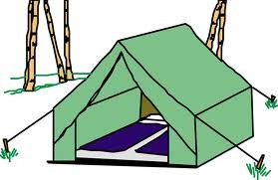


Pupil School
Parents
Hearing professional

Each tent rope represents a collaborator around the pupil.
All tent ropes must be kept tight for the tent to stand firmly 14


    - A constructive and continuous network for collaboration between the pupil, parents, school and hearing professional is crucial.

Collaboration regarding the pupil
    - Network meetings for all partners should be held at agreed intervals.
    - Transition periods are vulnerable – the school must take responsibility for the transfer of knowledge from former to future teachers.

    - The school is responsible for applying relevant information to everyone around the pupil – classmates, new teachers, substitute teachers.
Foto: Oscar Scott Carl
    - Note: Information to the classmates and their parents – who does what? Involve the hearing professional in this.

15

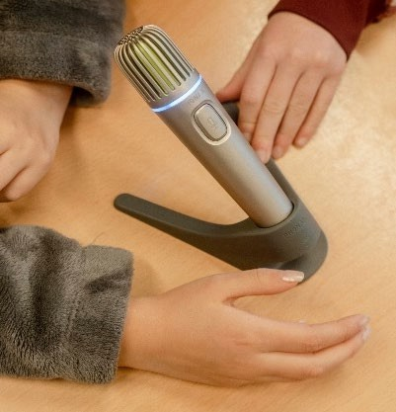
Hearing Assistive Technology (HAT)

- HAT gives access to clear sound over DISTANCE and in NOISY

16

environment.
      - HAT is wireless and transmits from microphones to a receiver connected to the pupil’s hearing devices (Hearing aid, Cochlear Implant).
      - Microphones for teachers and pupils.
      - The teacher reminds pupils to use the microphones.
      - The teacher mic can be attached to Auditory-Visual equipment (smartboard, computer).
      - The teacher mic can be changed into a group mic for group work.
      - Can easily be moved from one classroom to another.
      - Let the pupils in class take turns being responsible for charging and moving the HAT.
      - Advise or course for the classmates on how to use HAT is relevant.

Ressources

Glem det! A Norwegian film that explains hearing loss with sound examples. Shows issues in school life from the perspective of two young people with hearing loss (automatic subtitles in national languages applies). 30 minutes.

Article on chunking from the English website mindtools.com.

The Internet company succesforkidswithhearingloss.com from the USA that supplies relevant resources on many issues relating to teaching pupils with hearing loss.

Info on distance teaching with students with hearing loss.
17

