The best seating arrangement for hearing-impaired pupils
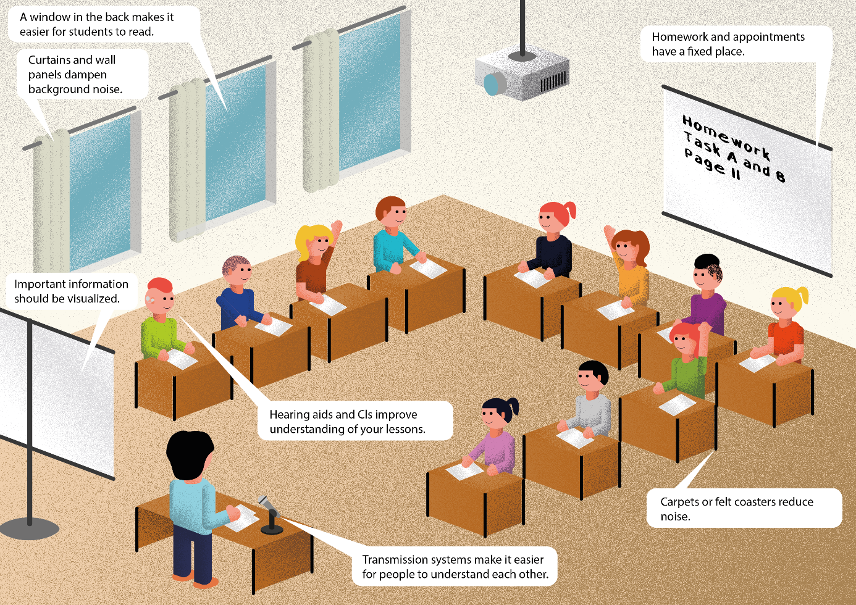

1. Seating arrangement
The seating arrangement should fit the class size, the room size and the teaching style.
It is best for the class to sit in a U-shape or in a semicircle (see illustration). Then the hearing impaired pupil can see everyone well.

2. Seat

2.1 Distance
The hearing impaired pupil sits 1-2 m away from the teacher.
Why? The further the distance, the harder it is to understand the teacher's voice.
Principle: 1 m distance makes the teacher's voice 6 dB quieter. This is measurable.
2 m makes the voice 12 dB softer. After 3 m, the voice is already 18 dB quieter.

2.2 Useful sound
The useful sound (= teacher's voice) should always be 6dB louder than the background noise.

2.3 Background noise
All ambient noise is background noise. Background noise disturbs communication. Background noise makes it very difficult to understand speech. If the background noise is very loud, the hearing-impaired pupil cannot understand anything.

2.4 Seat neighbour
A quiet seatmate can be a good buddy for the hearing-impaired pupil. For example, the buddy can help to think about technology.

2.5 Seating for pupils with one-sided hearing impairment
When there is noise, a unilaterally hearing-impaired pupil may have difficulty understanding speech.
If there is background noise, he has to concentrate very hard.
Often the hearing-impaired pupil does not understand speech when spoken to in the hearing-impaired ear.
It is then more difficult for him to understand a conversation.
The unilaterally hearing-impaired pupil sits with the good hearing ear facing the teacher.
A swivel chair helps the hearing-impaired pupil to turn quickly towards his classmates. This way he can also hear their answers well.

3. Enable lip reading

3.1 Eye contact
The hearing-impaired pupil can see the faces of teachers and classmates.
This enables him to recognise the mouth image and the different facial expressions well.

3.2 Sunlight
The hearing-impaired pupil sits with his back to the window.
Then he does not have to look against the sunlight and is not blinded.

4. Different learning (didactics and methodology)
The seat of a hearing-impaired pupil depends on the form of learning in class.
The following points are important:
- Proximity to the teacher
- Little or no disturbing noise
- A quiet neighbour can be helpful
- Eye contact is possible
- The light is not blinding
The hearing-impaired pupil sits in such a way that all the above points apply.

Sometimes there are group tables in the classroom. A seating semicircle in front of the blackboard is good for class discussions and presentations. This way everyone can see each other well.

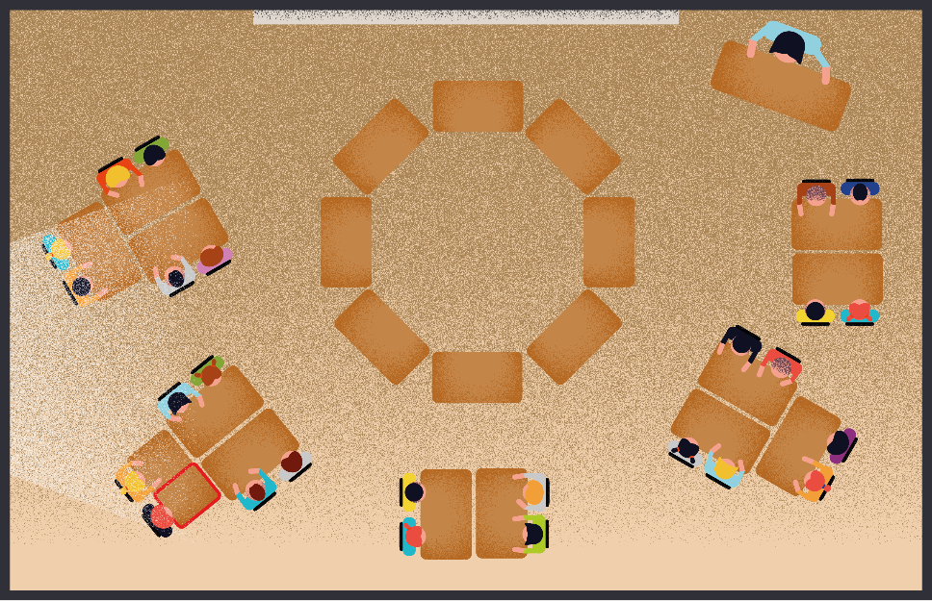

4.1 Frontal teaching
The teacher teaches from the front. There is little pupil interaction.
The desks are in a U-shape or in a semicircle.
The hearing-impaired pupil sits in the U-shape in the front and in the semicircle in the
middle.
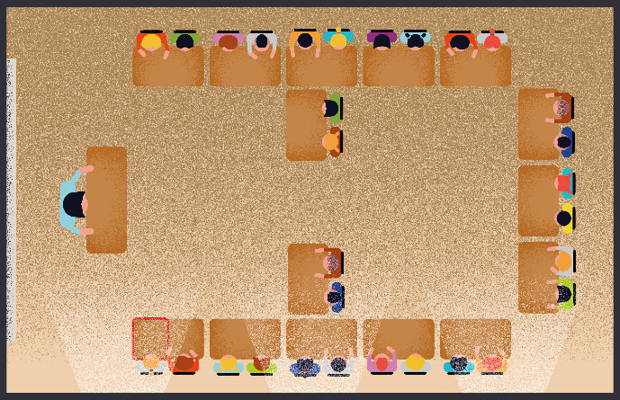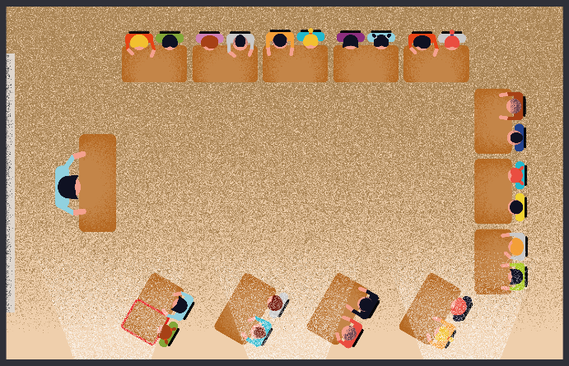

4.2 Open form of teaching
Pupils work alone, with a partner or in a group.
The hearing impaired pupil sits in a quiet place in the class.
The work material for all pupils is far away from the hearing impaired pupil. Then the other pupils do not disturb the hearing-impaired pupil when they fetch material.
In partner work, the hearing-impaired pupil sits opposite the partner. The pupils can look at each other.
For group work, the group sits with the hearing-impaired pupil in another room.

Checklist:The best seating arrangement for hearing-impaired pupils
Is the hearing-impaired pupil seated at the front of the class?
Does the hearing-impaired pupil have a quiet neighbour?
Does the hearing-impaired pupil have sunlight at his back?
Can the hearing-impaired pupil see the teacher clearly?
Can the hearing-impaired pupil see all the other pupils well?

References:
Reich, K. (Hg.): Methodenpool. In: url: http://methodenpool.uni-koeln.de
Last accessed: 27.06.2022

Schneider O, Hennies J, Jäger S, Rauner R, Schäfer K, Schulz W, Stecher M (2021):
Leitlinien guter Unterricht. Arbeitskreis Unterricht, Berufsverband Deutscher Hörgeschädigtenpädagogen e. V. Online verfügbar unter www.bdh-guter-unterricht.de Last accessed: 27.06.2022

Truckenbrodt, T., Leonhardt, A. (2016): Schüler mit Hörschädigung im inklusiven Unterricht. München: Ernst Reinhardt Verlag

