The best hearing technology for hearing-impaired pupils
Hearing technology includes all technical devices available to hearing-impaired people. This includes personal hearing aids and supplemental hearing systems. With these necessary aids, hearing-impaired pupils can follow what is going on in class more easily. This helps hearing-impaired pupils to better absorb and understand what is being taught.

1. Individual hearing aids
There are hearing aids and implantable hearing aids. The ear, nose and throat doctor diagnoses the child's hearing impairment and prescribes the appropriate technical hearing aid depending on the hearing loss. These hearing aids must be regularly maintained and checked. Batteries need to be changed or recharged regularly.

1.1 Hearing aids
Hearing aids help if the child is hard of hearing. The audiologist will fit the hearing aids.

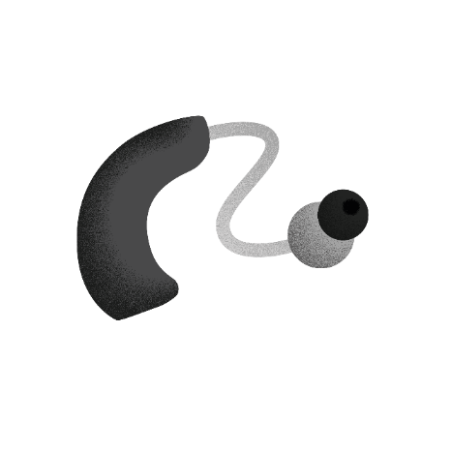
1.1.1 Behind-the-ear (BTE) hearing aids
Hearing-impaired pupils usually wear BTE devices. The BTE hearing aid is worn behind the ear. The hearing aid amplifies sound and transmits it directly to the ear.

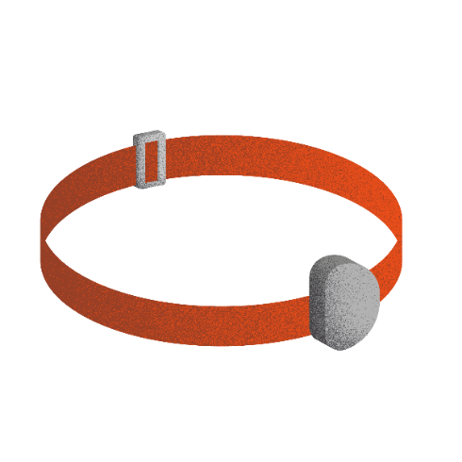
1.1.2 Bone conduction hearing aids
Bone conduction hearing aids are suitable for hearing-impaired pupils with damage to the outer or middle ear. The hearing device transmits sound via vibration to the bone behind the ear. Through the bone, the sound is sent directly to the inner ear. This allows the hearing-impaired pupil to hear. The bone conduction hearing aid is worn with a headband or attached to an adhesive adapter.

1.2 Implantable hearing systems
An implantable hearing system consists of several parts. The visible parts are worn on the outside of the head. Other parts are implanted. This hearing system helps people with profound hearing loss, with damage to the outer, middle or inner ear.

You can read more about hearing technology on Advanced bionics' website here (cochlear implants only).
You can read more about hearing technology on Cochlears website here.
You can read more about hearing technology on Medels website here.
You can read more about hearing technology on Sophonos website here.

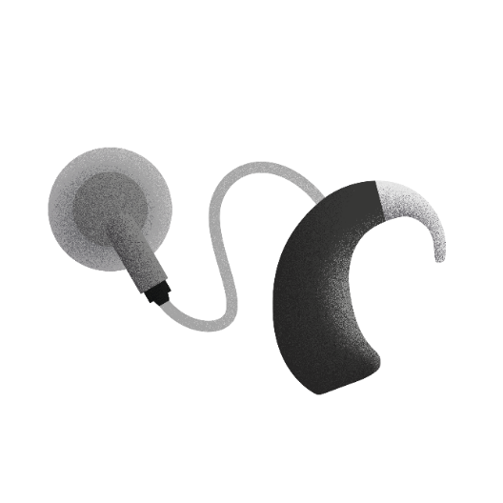
1.2.1 Cochlear implant (CI)
Cochlear implants help hearing-impaired pupils with profound hearing loss or hearing-impaired pupils who are profoundly deaf. The CI is made up of several components. The sound processor and the transmitter are visible on the outside. The implant is located under the skin behind the ear.
Cochlear implants (CI) and implantable hearing systems are implanted and fitted in CI centres or clinics.

1.2.2 Partially implantable hearing systems

Middle ear implant
The sound processor is located on the outside of the head. The implant is located in the middle ear and transmits sound to the inner ear. This allows the pupil to hear.

Bone conduction implant
The sound processor is located on the outside of the head. The implant is placed in the bone of the skull behind the ear. The implant transmits sound vibrations through the bones of the skull directly to the inner ear. This allows the pupil to hear.

2. Additional hearing systems
For hearing aids and implants, there are additional hearing systems: individual hearing transmission systems, classroom sound systems and pupil microphones. Additional hearing systems optimise listening in a noisy environment or when the speaker is at a distance. Hearing systems need to be powered or charged.

2.1 Hearing transmission system and pupil microphones
The hearing transmission system consists of a microphone for the teacher and additional microphones for pupils. The system is connected to the receivers on the hearing aid or implant.
The wireless microphones (one microphone for the teacher and separate pupil microphones) transmit the voice of the speaker directly to the receivers of the hearing aid or implant. In this way, the hearing-impaired pupil can understand speech well without background noise, as well as speech over distance.
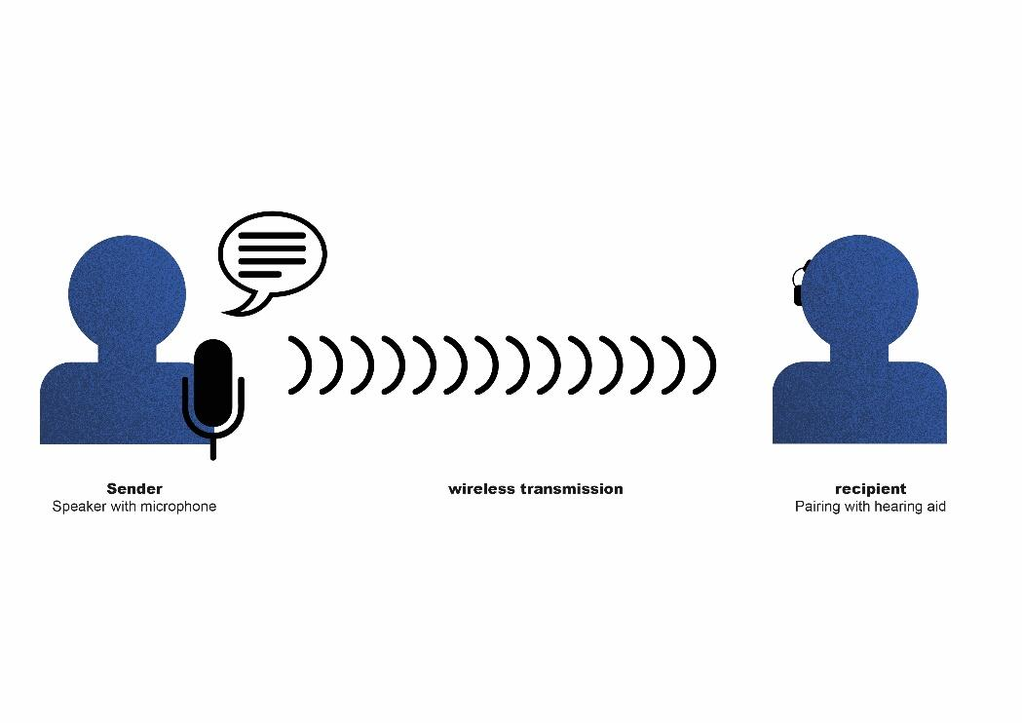
A multimedia hub connects the wireless transmission system to:
- PC, tablet
- Smartboard, TV
- MP3 player
Read more about wireless transmission systems on Phonaks website.

The following film shows how a hearing-impaired pupil hears in noise without and with the help of a digital transmission system and pupil microphones:

2.2 Classroom sound system / Soundfield system
The wireless soundfield amplification system improves the acoustic conditions for teachers and all pupils in the classroom. The microphone picks up the voice of the speaker and sends the speech to the loudspeaker. The loudspeaker spreads the speech evenly throughout the classroom. This way, everyone in the classroom can understand well, regardless of where they are seated.

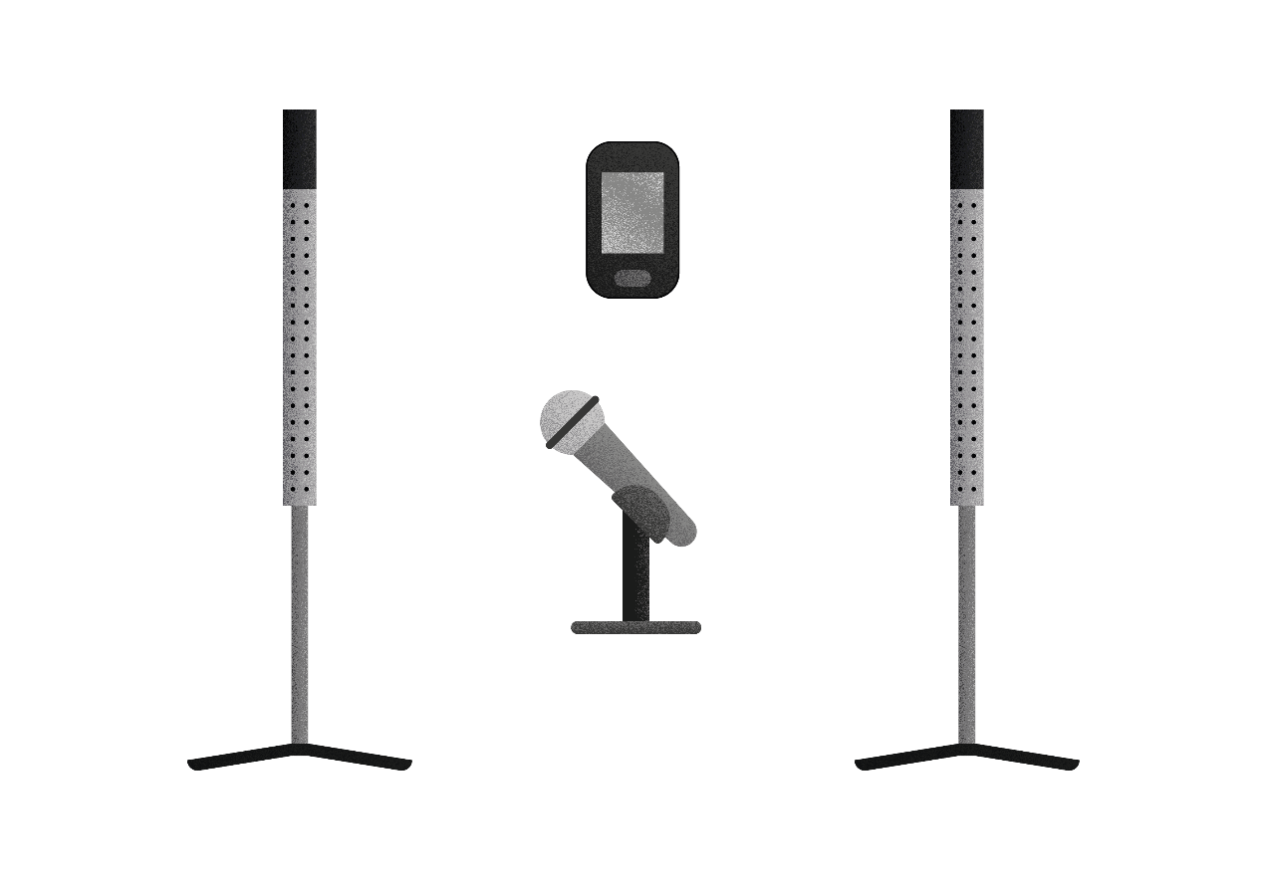

Checklist:The best hearing technology for hearing-impaired pupils
Does the pupil wear his hearing aids or cochlear implants regularly?
Does the pupil take care that his personal hearing aids or cochlear implants are working (e.g. full batteries or charged rechargeable batteries)?
Is the teacher’s transmitter of the wireless transmission system working?
Are the receivers connected to the wireless transmission system?
Are the pupils’ microphones charged?
Are the pupils’ microphones working?
Are the pupils’ microphones connected to the wireless transmission system?
Are the pupils’ microphones switched on when speaking?
Is the loudspeaker of the soundfield amplification system switched on?
Are the pupils’ microphones in a fixed and safe place when not in use?

References:
Schneider O, Hennies J, Jäger S, Rauner R, Schäfer K, Schulz W, Stecher M (2021).
Leitlinien guter Unterricht. Arbeitskreis Unterricht, Berufsverband Deutscher Hörgeschädigtenpädagogen e. V. Available online at: www.bdh-guter-unterricht.de Last accessed: 12.03.2023

View Medels website her. Last accessed: 12.03.2023

View Phonaks website here. Last accessed: 12.03.2023

Watch a film about additional hearing systems here.
Last accessed: 12.03.2023

Beratungslehrkräfte des Landesförderzentrums Hören und Kommunikation, Schleswig (2022): Hörgeschädigte Kinder und Jugendliche, Informationen für Eltern und Lehrkräfte. Informationsbroschüre.

