The best classroom acoustics for hearing-impaired pupils

Poor acoustic conditions in classrooms are bad for learning. Good classroom acoustics are important so that the hearing-impaired pupil can understand well. The pupil should have little effort in listening and understanding. If the listening effort is too great, the hearing-impaired pupil will learn poorly. The pupil cannot concentrate on the subject matter. A prerequisite for good understanding in the room is a low reverberation time, good speech intelligibility, and a good useful sound – background sound ratio. Technical experts measure the acoustic conditions of a classroom with special measuring devices. Educators can use apps to measure acoustic conditions in the classroom.

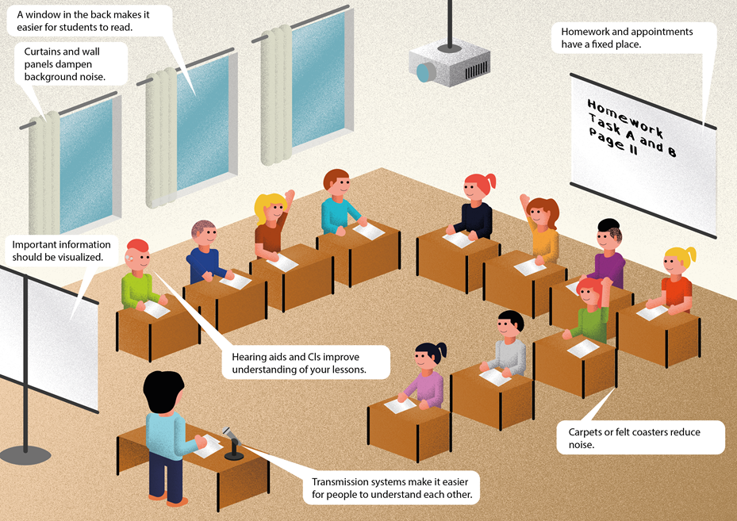

1. Classroom acoustics and acoustic conditions
In classrooms, a sound level is usually between 65dB and 75dB.
A sound level of 55dB is optimal for good learning conditions.
Room acoustics is the propagation of the sound in a room, in this case in the classroom. Sound propagates differently in space. It depends on the size and shape of the room and the materials in the classroom.

1.1 Reverberation time
Good room acoustics are achieved with a low reverberation time. There is a sound in the classroom. The ceiling, walls and furniture reflect the sound until it's gone. All sound reflections together are called reverberation. The reverberation time is the time from the creation of the sound to its disappearance. The reverberation time must be as short as possible. Many sound-insulating materials shorten the reverberation time. These materials are carpets, curtains, pillows, open shelves, ceilings made of acoustic material. The regulation says: In inclusive classrooms, the reverberation time must not be more than 0.45 sec. The abbreviation for reverberation time is RT. Measuring devices measure the time until the sound is 60 dB quieter. We are talking about RT60.
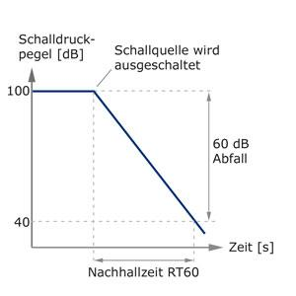

Classrooms with a reverberation time of 2 seconds are reverberant.
Note: The higher the reverberation time, the lower the understanding of speech in this classroom.
The reverberation becomes smaller the more sound-absorbing surfaces such as curtains, upholstered furniture, carpets or people are in the room. Suspended ceilings, open doors and windows also dampen the reverberation.

1.2 Speech intelligibility (Speech transmission Index: STI)
The intelligibility of spoken language in classrooms can be checked. The unit of measurement for speech intelligibility is the Speech Transmission Index (STI). Measuring speech intelligibility with a specific acoustic signal shows the intelligibility of the received signal at different measurement points.
It is shown in the table below.
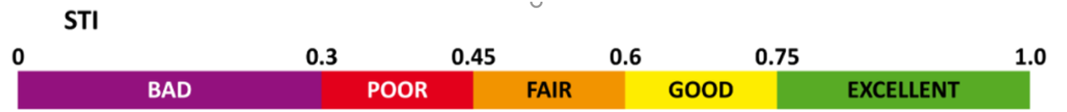

The sound pressure level, the background noise, the reverberation time and useful sound – background sound ratio influence speech intelligibility. This measurement is carried out by technical experts.

1.3 Improving speech intelligibility
Speech intelligibility is improved by optimizing room acoustics, avoiding background noise, and using certain teaching methods.
A high noise level in the classroom can be reduced by
- clear rules of conversation,
- use of "talking stones" (only those who have the stone in their hand may talk),
- have all materials ready before the lesson starts,
- writing down the material list at the beginning of the lesson,
- a learning clock shows the length of the working period,
- use quiet teaching materials: e.g. dices made of rubber and not plastic or wood

1.4 Useful sound
The useful signal of speech (S=speaker's voice), must be significantly higher than the interference signal (N=noise). The useful sound should be at least 15 dB louder than the background noise (S-N=15 dB). The useful sound, also direct sound, should reach the listener (= pupil) without reflections as quick as possible.

1.5 Noise and diffuse noise
Any background noise is noise. Noise interferes with communication. Noise makes it very difficult to understand speech. If the background noise is very loud, the hearing-impaired pupil cannot understand anything. Disturbing noises in everyday school life are external noises from open windows, road traffic, noises from next door due to poor insulation, domestic systems (heating, ventilation, air conditioning), media technology devices (projectors, computers), noises that come from pupils.
Diffuse sound is reflected multiple times off the walls until it reaches the listener (= pupil).

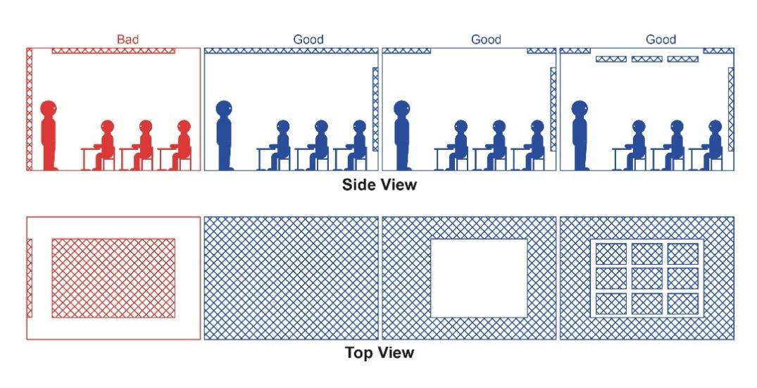

1.6 Location of the classroom
The room acoustics in the classroom need to be improved. Discuss the location of the room:
- Is it near a noisy street?
- Is the ambient noise particularly high here?

Preliminary considerations:
- Is there a classroom in the school that is more quiet?
- Is there a possibility to swap?

Measures to improve classroom acoustics
There are factors in the classroom design that may make noise quieter.
You can reduce the reverberation time by:
- acoustic suspended ceilings made of a sound-absorbing material
- Sound-absorbing wall panels or corkboards on the wall in the height range of the heads of sitting and standing people
- table pads
- open shelves
- curtains

You can reduce noise by:
- carpet or sound-absorbing rubber or linoleum floor coverings
- felt glides or tennis balls under chair legs on hard floors
- table pads for reflecting surfaces
- switching off media technology devices that are not required (e.g. projectors)
- low-noise building services systems
- soundproofing measures on windows and doors

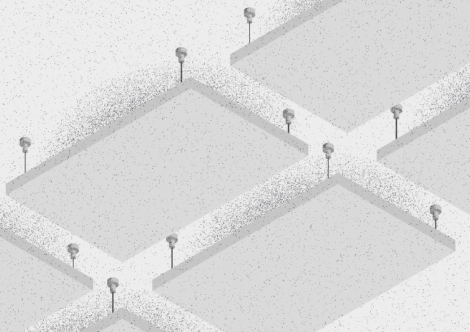

Checklist: The best classroom acoustics for hearing-impaired pupils
Is the volume in the room less than 65 dB during silent work periods?
Is the reverberation time less than 0.45 seconds?
Are there:
- acoustic ceilings made of a sound-absorbing material?
- sound-absorbing wall panels or corkboards?
- carpets or sound-absorbing floor coverings?
- felt glides or tennis balls under chair legs on hard floors?
- open shelves?
- curtains?
- table pads?
- Is there a quieter classroom?
- Noises from outside cannot be heard, e.g. normal traffic noise, classmates in the schoolyard.
- Noises from neighbouring classes cannot be heard.
- Are the lights and heating system in the classroom quiet?
- Is the media technology equipment quiet during use?

Apps:
myraumklang app
rockfon raumakustik app

References:
Deutsche Gesetzliche Unfallversicherung e.V. (DGUV) (Hrsg.) (2012, aktualisiert 2018): Klasse(n) – Räume für Schulen. DGUV Information 202-090

Jacobs, H., Schneider, M., Wisnet, M. (2004): Hören – Hörschädigung: Informationen und Unterrichtshilfen für allgemeine Schulen. Der Paritätische Wohlfahrtsverband, Landesverband Hessen

Landesverband Bayern der Schwerhörigen und Ertaubten e.V. (2019): Pro Inklusion 2/2019
Schneider O, Hennies J, Jäger S, Rauner R, Schäfer K, Schulz W, Stecher M (2021):
Leitlinien guter Unterricht. Arbeitskreis Unterricht, Berufsverband Deutscher Hörgeschädigtenpädagogen e. V. Online verfügbar unter www.bdh-guter-unterricht.de Last accessed: 27.06.2022

Truckenbrodt, T., Leonhardt, A. (2016): Schüler mit Hörschädigung im inklusiven Unterricht. München: Ernst Reinhardt Verlag

