Interpreting services for hearing-impaired pupils

1. Interpreting services
Various interpreting services are available to support hearing-impaired pupils in the classroom.
There are on-site sign language interpreters, speech-to-text reporters and digital software to convert spoken language into text.

1.1 Sign language interpreters
Sign language interpreters translate spoken language into sign language on site.

1.2 Remote interpreting services
With remote interpreting, the interpreter is not in the room but is connected online. The interpreter writes down spoken language or translates into sign language. The hearing-impaired pupil is connected to the interpreter via computer, tablet or mobile phone. Remote interpreting is independent of location.



1.2.1 Speech-to-text reporters
In written language interpreting, the teacher is digitally connected to the remote interpreter. The speech-to-text reporter writes down what is heard and sends it digitally to the hearing-impaired pupil. In this way, the hearing-impaired pupil can read the text and knows what the teacher is saying. The pupil can read the text and ask questions in the chat. Speech-to-text reporters can interpret in different languages.

1.2.2 Sign language interpreter
The pupil sees the interpreter via video on the computer, tablet or mobile phone. This interpreter is called a sign language interpreter.
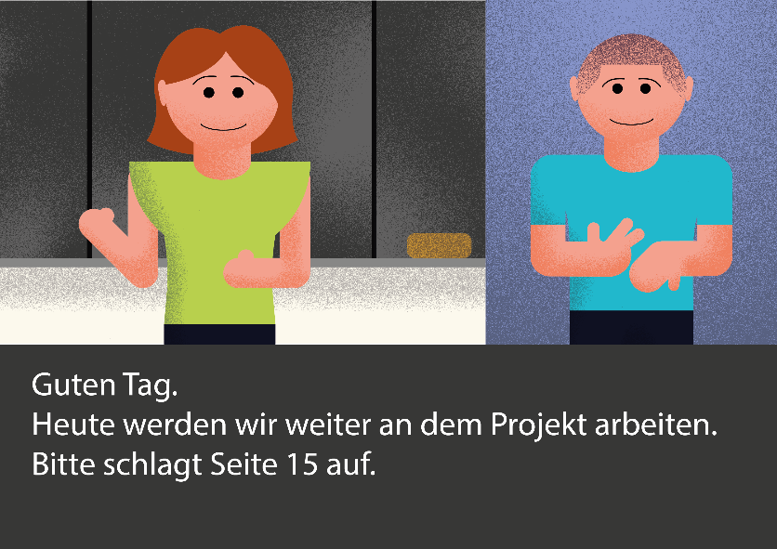
Hello.
Today we will continue to work on the project.
Please open page 15.

1.3 Converting spoken language into text using computer software
Computer software can be used immediately and costs less money than interpreting services. Different languages can be selected. There are different platforms for this.

2. Requirements
For remote interpreting services, schools need a good, reliable electricity network and their own Wi-Fi.
The teacher needs a microphone that can be connected to a digital device.
The hearing-impaired pupil can read or use sign language.
The pupil has a digital terminal and is familiar with the technology.

Checklist: Interpreting services for hearing-impaired pupils
Is there a stable internet connection in the school and classroom?
Does the teacher have a teacher transmitter?
Does the hearing-impaired pupil have a tablet or computer?
Can the hearing-impaired pupil use the technology for his own purposes?
Can the hearing-impaired pupil read well enough to understand the texts of the
written language interpreter?
Does the hearing-impaired pupil use and understand sign language (signs to accompany spoken language, speech-supporting signs)?

References:
View VerbaVoices website her. Last accessed: 12.11.2025

